# Online Appendix – not for publication

Table of contents

Appendix A: Two polar models of labor market power 47

Case 1: Employee-side labor market power – efficient bargaining model 47

Case 2: Employer-side labor market power – monopsonistic labor market 49

Appendix B: Details on deriving firm labor market power 51

Appendix B.1: Deriving a parameter for labor market power 51

Appendix B.2: Cost-minimization with labor market power 53

Appendix B.3: Comparison with De Loecker, Eeckhout, & Unger (2020) 56

Appendix C: Details on the data 58

Appendix C.1: Data source and variable definitions 58

Appendix C.2: Sample firms’ characteristics, and production function estimation results for the baseline specification 61

Appendix C.3: Calculation of capital stocks 64

Appendix C.4: Constructing a firm-specific price index 67

Appendix D: Two-digit industry-level changes of output elasticities 68

Appendix E: Identifying moments 73

Appendix F: Robustness checks and additional results 74

Appendix F.1: Additional results for the baseline specification of the main text 74

Appendix F.2: Robustness check: Using a Cobb-Douglas production model 84

Appendix F.3: Robustness check: Time-varying Cobb-Douglas 92

Appendix F.4: Robustness check: Flexible labor input 97

Appendix F.5: Robustness check: Omitting the firm-specific price correction 102

Appendix G: Firm-product-level labor market power measures when having no information on product-/task-specific wages. 107

Appendix H: Mechanisms behind large and growing firm labor market power 109

Appendix I: Decomposition of aggregate labor share changes in Germany 114

Appendix J: Labor shares, output elasticities of labor, and product and labor market power for firms of different size 116

Appendix K: Industry-level within- and between-firm changes 122

References (online Appendix) 125

## Appendix A: Two polar models of labor market power

This section derives two examples on how labor market imperfections translate into labor market power that can be measured by wedges between wages and marginal revenue products of labor. I first discuss a simple efficient bargaining model in which employees possess labor market power. Following this, I present a model of monopsonistic labor markets. In both models, labor market power materializes in wedges between wages and marginal revenue products of labor. The framework of the main text nests both models who are polar labor market power models, where either only the firm or only the workforce has labor market power. For a theoretical combination of both models, I refer the interested reader to Falch & Strøm (2007). Notably, I do not intend to describe strategic interactions between product and labor market power with these models as I am only interested in understanding how output elasticities and labor and product market power relate to labor shares without drawing any inferences on the causal relation between labor and product market power. Therefore, the purpose of this section is simply to illustrate how labor market power translates into wedges between wages and marginal revenue products, which is the measure of labor market power in the main text. Throughout this section, I heavily draw on Dobbelaere & Mairesse (2013).

### Case 1: Employee-side labor market power – efficient bargaining model

Firms compete in imperfect product markets. As in Dobbelaere & Mairesse (2013), risk-neutral workers collectively bargain with the firm over wages ($w_{it}$) and employment ($L_{it}$). Ultimately, this coordination of labor supply, i.e. the absence of a competitive pool of workers that compete over firms’ labor demand, will lead to employee-side labor market power.

Employees maximize their utility function, given by:

|  |  |
| --- | --- |
| (A.1) | $$U\left(w_{it}, { L}_{it}\right)=w_{it}{ L}_{it}+\left({ \overline{L}}_{it}-{ L}_{it}\right){\overline{w}}_{it},$$ |

where ${\overline{w}}_{it}≤w_{it}$ is the reservation wage and ${ \overline{L}}_{it}$ is the competitive employment level.

As in the main text, firms produce output using the production function:

|  |  |
| --- | --- |
| (A.2) | $$Q_{it}=Q_{it}\left(.\right)=Q_{it}\left(L_{it},K_{it},M_{it},e^{ω_{it}}\right).$$ |

Capital is a fixed production input. For mathematical convenience, I assume that labor and intermediate inputs are both flexible. This limits the source of labor market power to pure bargaining power within the Nash-bargaining process between firms and employees (e.g. due to the presence of unions). However, generally, one can additionally allow for inflexible contracts to create employee-side labor market power by defining that a part of the wage bill cannot be adjusted in the short-run.[1] With denoting revenue, this implies that firms maximize the following short-run objective function:

|  |  |
| --- | --- |
| (A.3) | $$Π_{it}=R_{it}-w_{it}L_{it}-z_{it}M_{it} ,$$ |

where $z_{it}$ denotes the unit costs for intermediate inputs. Intermediate input markets are perfectly competitive. Thus, firms can unilaterally set ${ M}_{it}$ given $z_{it}$ (this is not necessary but eases computation). Since employees collectively bargain with firms, wage and employment levels are decided from a bargaining game in which employees have some degree of bargaining power, denoted by $ϕ_{it} ϵ [0,1]$. As shown in Dobbelaere & Mairesse (2013), the outcome of this bargaining is the generalized Nash-solution:

|  |  |
| --- | --- |
| (A.4) | $$\max_{w_{it}, { L}_{it},{ M}_{it}}{{(w_{it}L_{it}+\left({ \overline{L}}_{it}-L_{it}\right){\overline{w}}_{it})}^{ϕ_{it}}{(R_{it}-w_{it}L_{it}-z_{it}M_{it})}^{1-ϕ_{it}}}.$$ |

Maximization with respect to $w_{it}$ and $L_{it}$ gives:

|  |  |
| --- | --- |
| (A.5) | $$w_{it}={\overline{w}}_{it}+{χ_{it}\left[\frac{R_{it}-w_{it}L_{it}-z_{it}M_{it}}{L_{it}}\right]}$$ |

and

|  |  |
| --- | --- |
| (A.6) | $$w_{it}={MRPL}_{it}+{ϕ_{it}\left[\frac{R_{it}-{MRPL}_{it}L_{it}-z_{it}M_{it}}{L_{it}}\right]},$$ |

where $χ_{it}=\frac{ϕ_{it}}{1-ϕ_{it}}$ denotes the relative extent of rent sharing. In this simple framework all the labor market power of the workforce is collected in $ϕ_{it}$. As equations (A.5) and (A.6) show, when employees possess positive bargaining power ($ϕ_{it}>0$), wages are above the marginal revenue product of labor. Note that equations (A.5) and (A.6) also nicely show that if firms can hire from a competitive pool of workers that do not coordinate their actions (i.e. a case where firms and workers do not bargain with each other), wages and marginal revenue products of labor equalize. In that sense, the source of labor market power in the efficient bargaining model is the fact that firms are bound to hire workers from an organized community. This essentially constitutes a hiring friction (more details can be found in McDonald & Solow (1981)).

### Case 2: Employer-side labor market power – monopsonistic labor market

On a monopsonistic labor market, firms set wages such that wages are below the marginal revenue product of labor. To do so, firms need to face a labor supply curve that is imperfectly elastic (Dobbelaere & Mairesse (2013)). Imperfectly elastic labor supply curves are typically motivated by labor market frictions that prevent workers from a costless switching between many firms. Among others, such frictions include imperfect information, local preferences, or moving costs (Boal & Ransom (1997); Burdett & Mortensen (1998); Bhaskar and To (1999); Dobbelaere & Mairesse (2013)). In the following, I derive an expression showing how imperfectly elastic labor supply curves translate into labor market power that allows firms to pay wages below marginal revenue products of labor.

Firms produce output using the production function (A.2). Now, firms do not bargain with a community of workers. Instead, firms unilaterally set wages. Consequently, the firm’s objective is to maximize the following version of equation (A.3):

|  |  |
| --- | --- |
| (A.7) | $$\max_{{ L}_{it},{ M}_{it}}{Π_{it}(w_{it},{ z}_{it},{ L}_{it},{ M}_{it})=R_{it}(L_{it},{ M}_{it})-w_{it}(L_{it})L_{it}-z_{it}M_{it}}.$$ |

Maximization with respect to labor gives:

|  |  |
| --- | --- |
| (A.8) | $${MRPL}_{it}=w_{it}+\frac{∂w_{it}}{∂L_{it}}L_{it}=w_{it}(1+\frac{1}{ε_{it}^{L}}).$$ |

where $ε_{it}^{L}≥0$ denotes the labor supply elasticity. After reformulating equation (A.8), one receives:

|  |  |
| --- | --- |
| (A.9) | $$\frac{ε_{it}^{L}}{1+ε_{it}^{L}}{MRPL}_{it}=w_{it}.$$ |

Equation (A.9) shows that only if firms face an imperfectly elastic labor supply curve, unilateral wage setting of a firm leads to wages that are below the marginal revenue product of labor. In absence of employee-side adjustment frictions that give firms’ labor market power, we have $ε_{it}^{L}=∞$ and $w_{it}={MRPL}_{it}$.

A simple combination between the two models discussed above can be formalized by defining that the outside option or the reservation wage in the efficient bargaining model equals the wage in a monopsonistic labor market. For a model applying this idea, I refer the interested reader to Falch & Strøm (2007). In an alternative approach, the online Appendix B.3 shows how one can extend a standard firm-level cost-minimization framework to allow for arbitrary firm- and employee-side labor market power.

## Appendix B: Details on deriving firm labor market power

### Appendix B.1: Deriving a parameter for labor market power

First, I derive equation (3) from the main text, which measures the degree of firms’ output market power. This is done from a cost-minimization framework. The key assumption to derive (3) as a measure of output market power is that intermediate input markets are *flexible and that intermediate input prices are exogenous to firms*, i.e. that unit costs for intermediates equal marginal revenue products of intermediate inputs (De Loecker & Warzynski (2012)). Using firms’ production function (1) and the periodic cost function, $C\left(.\right)=r_{it}K_{it}+w_{it}L_{it}+z_{it}M_{it}$, where $r_{it}$, $w_{it}$, and $z_{it}$ respectively denote the unit costs for capital ($K_{it}$), labor ($L_{it}$), and intermediates ($M_{it}$), we can formulate the following Lagrangian:

|  |  |
| --- | --- |
| (B.1) | $$L_{it}=r_{it}K_{it}+w_{it}L_{it}+z_{it}M_{it}+λ_{it}\left(Q_{it}-Q_{it}\left(.\right)\right),$$ |

Given the above assumptions, the following first order condition holds:

|  |  |
| --- | --- |
| (B.2) | $$z_{it}=λ_{it}\frac{∂Q_{it}}{∂M_{it}}.$$ |

where $λ_{it}=\frac{P_{it}}{μ_{it}}$, with $P_{it}$ and $μ_{it}$ being the firm’s output price and the firm’s price setting output market power (De Loecker & Warzynski (2012)). Expanding (B.2) with $\frac{M_{it}}{Q_{it}}$ and reformulating leads to equation (3) of the main text:

|  |  |
| --- | --- |
| (3) | $$μ_{it}=θ_{it}^{M}*\frac{P_{it}Q_{it}}{z_{it}M_{it}},$$ |

where $θ_{it}^{X}=\frac{∂Q_{it}}{∂X_{it}}\frac{X_{it}}{Q_{it}}$ denotes the output elasticity of input $X=\left\{L,M,K\right\}$.

From equation (2) of the main text, i.e. from $\left(1+τ_{it}^{L}\right)=\frac{w_{it}}{{MRPL}_{it}}$, one can derive a similar expression. To see this, first use the assumptions that intermediates are a flexible input and that input prices are exogenous to firms, which implies that marginal revenue products of intermediate inputs equal intermediate input unit costs (we applied these assumptions already to derive (3) above, i.e. we could also reformulate (3) and substitute it in). From that, we can expand (2) in the following way:

|  |  |
| --- | --- |
| (B.3) | $$\left(1+τ_{it}^{L}\right)=\frac{w_{it}}{{MRPL}_{it}}\frac{{MRPM}_{it}}{z_{it}}=\frac{w_{it}}{{MPL}_{it}*{MR}_{it}}\frac{{MPM}_{it}*{MR}_{it}}{z_{it}},$$ |

where ${MRPM}_{it}$, ${MR}_{it}$, ${MPL}_{it}$, and ${MPM}_{it}$ respectively denote the marginal revenue product of intermediates, the marginal revenue, the marginal product of labor and the marginal product of intermediates. Rewriting (B.3) and expanding with $\left(\frac{\frac{M_{it}}{Q_{it}M_{it}}}{\frac{L_{it}}{Q_{it}L_{it}}}=1\right)$ gives:

|  |  |
| --- | --- |
| (B.4) | $$\left(1+τ_{it}^{L}\right)=\frac{w_{it}}{z_{it}}\frac{\frac{∂Q_{it}}{∂M_{it}}\frac{M_{it}}{Q_{it}}}{\frac{∂Q_{it}}{∂L_{it}}\frac{L_{it}}{Q_{it}}}*\frac{L_{it}}{M_{it}}=\frac{w_{it}}{z_{it}}\frac{θ_{it}^{M}}{θ_{it}^{L}}\frac{L_{it}}{M_{it}}.$$ |

Expanding with $\frac{P_{it}Q_{it}}{P_{it}Q_{it}}$, substituting (3) into (B.4), and rearranging gives equation (4) of the main text:

|  |  |
| --- | --- |
| (4) | $$μ_{it}=θ_{it}^{L}\frac{P_{it}Q_{it}}{w_{it}L_{it}}\left(1+τ_{it}^{L}\right),$$ |

Which, after using (3), is equivalent to:

|  |  |
| --- | --- |
| (B.5) | $$θ_{it}^{M}\frac{P_{it}Q_{it}}{z_{it}M_{it}}=θ_{it}^{L}\frac{P_{it}Q_{it}}{w_{it}L_{it}}\left(1+τ_{it}^{L}\right).$$ |

Finally, rearranging yields equation (5) of the main text:

|  |  |
| --- | --- |
| (5) | $$γ_{it}≡\frac{1}{\left(1+τ_{it}^{L}\right)}=\frac{θ_{it}^{L}}{θ_{it}^{M}}*\frac{z_{it}M_{it}}{w_{it}L_{it}},$$ |

where $γ_{it}$ denotes a measure of the firm’s labor market power.

### Appendix B.2: Cost-minimization with labor market power

In this section, I extent the cost-minimization framework of De Loecker & Warzynski (2012) to allow for imperfections on labor markets that create labor market power. For convenience, I start by only allowing for monopsonistic firm labor market power and subsequently discuss how one can further extent the described framework to additionally allow for employee-side labor market power.[2] The latter is important for explaining why some firms in the data pay wages above marginal revenue products of labor.

As in the main text, firms produce output using the production function:

|  |  |
| --- | --- |
|  | $$Q_{it}=Q_{it}\left(.\right)=Q_{it}\left(L_{it},K_{it},M_{it},e^{ω_{it}}\right).$$ |

Firms take intermediate input prices as given and have some wage setting market power in the labor market. To keep the derivations simple, I abstract from capital market imperfections. Together, this motivates the periodic cost function $C_{it}=w_{it}(L_{it})L_{it}+z_{it}M_{it}+r_{it}K_{it}$, where $w_{it}$, $z_{it}$, and $r_{it}$ are unit input costs for labor, intermediate inputs, and capital. Note that wages are a function of the firms’ amount of labor. As in the online Appendix B.1, firms minimize costs, which allows me to consider the following Lagrangian:

|  |  |
| --- | --- |
| (B.6) | $$L_{it}=r_{it}K_{it}+w_{it}\left(L_{it}\right)L_{it}+z_{it}M_{it}+λ_{it}\left(Q_{it}-Q_{it}\left(.\right)\right),$$ |

The first order conditions for $M_{it}$ and $L_{it}$ write:

|  |  |
| --- | --- |
| (B.7) | $$z_{it}=λ_{it}\frac{∂Q_{it}\left(.\right)}{∂M_{it}}$$ |

and

|  |  |
| --- | --- |
| (B.8) | $$w_{it}\left(1+\frac{∂w_{it}}{∂L_{it}}\frac{L_{it}}{w_{it}}\right)=w_{it}\left(1+\frac{1}{ε_{it}^{L}}\right)=λ_{it}\frac{∂Q_{it}\left(.\right)}{∂L_{it}},$$ |

where $λ_{it}=\frac{P_{it}}{μ_{it}}$ (as in the online Appendix B.1). $ε_{it}^{L}$ denotes the labor supply elasticity and $λ_{it}\frac{∂Q_{it}\left(.\right)}{∂X_{it}}$ is the marginal revenue product of production input $X=\{M,L\}$. Using this latter definition, we can show that (B.8) equals equation (2) of the main text:

|  |  |
| --- | --- |
|  | $$\frac{ε_{it}^{L}}{{1+ε}_{it}^{L}}=\frac{w_{it}}{{MRPL}_{it}}=\left(1+τ_{it}^{L}\right).$$ |

Reformulating (B.7) and (B.8) respectively gives:

|  |  |
| --- | --- |
| (B.9) | $$μ_{it}=θ_{it}^{M}*\frac{P_{it}Q_{it}}{z_{it}M_{it}}$$ |

and

|  |  |
| --- | --- |
| (B.10) | $$μ_{it}=θ_{it}^{L}*\frac{P_{it}Q_{it}}{w_{it}L_{it}}\frac{ε_{it}^{L}}{{1+ε}_{it}^{L}} .$$ |

(B.9) and (B.10) are equivalent to equations (3) and (4) of the main text. Combining (B.9) and (B.10) gives equation (5) of the main text, which I call (B.11) here:

|  |  |
| --- | --- |
| (B.11) | $$γ_{it}≡\left(1+\frac{1}{ε_{it}^{L}}\right)=\frac{θ_{it}^{L}}{θ_{it}^{M}}*\frac{z_{it}M_{it}}{w_{it}L_{it}}.$$ |

Until now, we abstracted from worker-side labor market power, which, as can be seen from (B.11), would imply that $γ_{it}≥1$. Allowing for worker-side labor market power introduces an additional term in the Lagrangian (B.6) which allows for the outcome $γ_{it}<1$. Depending on the nature of this worker-side labor market power, one might even want to consider a dynamic optimization problem, as adjustment costs and worker-side labor market power are closely related.

In any case (be it a static or dynamic model), under the presence of worker-side labor market power, the first order condition for labor changes to:

|  |  |
| --- | --- |
| (B.12) | $$w_{it}\left(1+\frac{1}{ε_{it}^{L}}+F_{it}(.)\right)=λ_{it}\frac{∂Q_{it}\left(.\right)}{∂L_{it}},$$ |

where $-1≤F_{it}\left(.\right)≤0$ and the arguments of $F_{it}(.)$ depend on the specific source of workers-side labor market power and might potentially include dynamic factors (e.g. bargaining power, hiring/firing costs, etc.). Total firm labor market power (equation (5) of the main text) is then be given by:

|  |  |
| --- | --- |
| (B.13) | $$γ_{it}≡\left(1+\frac{1}{ε_{it}^{L}}+F_{it}\left(.\right)\right)=\frac{θ_{it}^{L}}{θ_{it}^{M}}*\frac{z_{it}M_{it}}{w_{it}L_{it}},$$ |

which, again, is equivalent to the expression used to measure labor market power in the main text. Finally, note that the index $i$ in $ε_{it}^{L}$ and $F_{it}(.)$ highlights that this framework is entirely consistent with simultaneously observing some firms in which the monopsonistic labor market power term (i.e. the inverse of the labor supply elasticity) dominates, while having other firms in the data in which the rent-sharing term $F_{it}\left(.\right)$ is in absolute terms larger than $\frac{1}{ε_{it}^{L}}$. The degree of each firm’s total firm labor market power, which is an average parameter across the firm’s entire workforce (see Mertens (2021)), depends on the net effect of rent-sharing and monopsonistic exploitation. This in turn depends on the firm’s workforce characteristics and labor market setting that are both unrestricted by the above production side framework as this framework is consistent with any labor market model and does not depend on the presence of specific workforce characteristics.

### Appendix B.3: Comparison with De Loecker, Eeckhout, & Unger (2020)

In this section, I show how one can transfer my estimates on product and labor market power to the markup estimates of De Loecker, Eeckhout, & Unger (2020). In particular, I show that their markup estimate, denoted by $μ_{it}^{DLEU}$ is a function of my product ( $μ_{it})$ and labor market power parameter ($γ_{it})$.

De Loecker et al. (2020) define a production model consisting of two production factors. One combines intermediate and labor inputs into a joint production factor, $V_{it}=M_{it}+L_{it}$, and the other is capital, $K_{it}$. Using a cost-minimization framework, as detailed above, they derive their markup from the wedge between the output elasticity of $V_{it}$ and its inverse expenditure share in revenues:

|  |  |
| --- | --- |
| (B.14) | $$μ_{it}^{DLEU}=θ_{it}^{V}*\frac{P_{it}Q_{it}}{P_{it}^{V}V_{it}}=θ_{it}^{V}\frac{P_{it}Q_{it}}{z_{it}M_{it}+w_{it}L_{it}},$$ |

Where $P_{it}^{V}$ is the (average) unit input cost of $V_{it}$ and $P_{it}^{V}V_{it}=z_{it}M_{it}+w_{it}L_{it}$. Note that $θ_{it}^{V}=θ_{it}^{M}+θ_{it}^{L}$ because bundling $M_{it}$ and $L_{it}$ into one production factor imposes a joint output elasticity for these two inputs. In absence of product and factor market distortions, we have: $θ_{it}^{V}=\frac{P_{it}^{V}V_{it}}{P_{it}Q_{it}}=\frac{z_{it}M_{it}}{P_{it}Q_{it}}+\frac{w_{it}L_{it}}{P_{it}Q_{it}}$.

Now consider that labor markets are characterized by some degree of labor market power, either hold by firms or workers. Intermediate input markets are competitive. As firms make separate decision on $M_{it}$ and $L_{it}$ we can consider separate first-order conditions for these two inputs. As can be seen from equations (B.7), (B.12), and (B.13), the first order conditions for $M_{it}$ and $L_{it}$ are:

|  |  |
| --- | --- |
| (B.15) | $$z_{it}=λ_{it}\frac{∂Q_{it}\left(.\right)}{∂M_{it}} ⇒ μ_{it}=θ_{it}^{M}*\frac{P_{it}Q_{it}}{z_{it}M_{it}}$$ |

and

|  |  |
| --- | --- |
| (B.16) | $$w_{it}γ_{it}=λ_{it}\frac{∂Q_{it}\left(.\right)}{∂L_{it}} ⇒ μ_{it}γ_{it}=θ_{it}^{L}*\frac{P_{it}Q_{it}}{w_{it}L_{it}}.$$ |

Substituting (B.15) and (B.16) into (B.14) gives:

|  |  |
| --- | --- |
| (B.17) | $$μ_{it}^{DLEU}=θ_{it}^{V}\frac{P_{it}Q_{it}}{θ_{it}^{M}\frac{P_{it}Q_{it}}{μ_{it}}+θ_{it}^{L}\frac{P_{it}Q_{it}}{μ_{it}γ_{it}}}.$$ |

Reformulating and using $θ_{it}^{V}=θ_{it}^{M}+θ_{it}^{L}$ finally gives:

|  |  |
| --- | --- |
| (B.18) | $$μ_{it}^{DLEU}=\frac{θ_{it}^{M}+θ_{it}^{L}}{θ_{it}^{M}γ_{it}+θ_{it}^{L}}μ_{it}γ_{it}.$$ |

Note that if labor markets are competitive ($γ_{it}=1$), equation (B.18) reduces to $μ_{it}^{DLEU}=μ_{it}$. With labor market power, the scaling factor $\frac{θ_{it}^{M}+θ_{it}^{L}}{θ_{it}^{M}γ_{it}+θ_{it}^{L}}$ adjusts for differences in firms’ input market power in input markets for intermediates and labor.

As can further be seen from equation (B.16), estimating the input wedge between labor’s output elasticity and expenditure share, combines product and labor market power and only measures true product market power if labor markets are competitive.

## Appendix C: Details on the data

### Appendix C.1: Data source and variable definitions

The data can be accessed at the “Research Data Centres” of the Federal Statistical Office of Germany and the Statistical Offices of the German Länder. Data request can be made at: <https://www.forschungsdatenzentrum.de/en/request>.

The statistics that I used are: *“AFiD-Modul Produkte”, “AFiD-Panel Industriebetriebe”, “AFiD-Panel Industrieunternehmen”, “Investitionserhebung im Bereich Verarbeitendes Gewerbe, Bergbau und Gewinnung von Steinen und Erden”, “Panel der Kostenstrukturerhebung im Bereich Verarbeitendes Gewerbe, Bergbau und Gewinnung von Steinen und Erden”*.

The following list presents an overview on the variable definitions of all variables that are used in this article:

* $L_{it}$: Labor in headcounts.
* $w_{it}$: Nominal wage (firm average), defined as gross salary + “other social expenses” (latter includes expenditures for company outings, advanced training, and similar costs).
* $K_{it}$: Capital derived by a perpetual inventory method (see online Appendix C.3), where investment captures firms’ total investment in buildings, equipment, machines, and other investment goods. Nominal values are deflated by a 2-digit industry-level deflator supplied by the statistical office of Germany.
* $M_{it}$: Deflated total intermediate inputs, defined as expenditures for raw materials, energy, intermediate services, goods for resale, renting, temporary agency workers, repairs, and contracted work conducted by other firms. Nominal values are deflated by a 2-digit industry-level deflator supplied by the statistical office of Germany.
* $z_{it}M_{it}$: Nominal values of total intermediate input expenditures.
* $P_{it}Q_{it}$: Nominal output / nominal total revenue, defined as total output, including, among others, sales from own products, sales from intermediate goods, revenue from offered services, and revenue from commissions/brokerage.
* $Q_{it}$: Quasi-quantity measure of physical output, i.e. $P_{it}Q_{it}$ deflated by a firm-specific price index (denoted by $π_{it}$, see definition of below).[3]
* Nominal value-added, defined as $P_{it}Q_{it}-$ $z_{it}M_{it}$.
* $π_{it}$: Firm-specific Törnqvist price index, derived as in Eslava, Haltiwanger, Kugler, & Kugler (2004). See the online Appendix C.4 for its construction.
* ${ms}_{it}$: Weighted average of firms’ product market shares in terms of revenues. The weights are the sales of each product in firms’ total product market sales.
* $G_{it}$: Headquarter location of the firm. 90% of firm’s in my sample are single-plant firms.
* $D_{it}$: A four-digit industry dummy. The industry of each firm is defined as the industry in which the firm generates most of its sales.
* $E_{it} (or in logs, e_{it} in the main text)$: Deflated expenditures for raw materials and energy inputs. Nominal values are deflated by a 2-digit industry-level deflator for intermediate inputs and which is supplied by the statistical office of Germany. $E_{it}$ is part of $M_{it}$.
* ${Exp}_{it}$: Dummy-variable being one, if firms generate export market sales.
* ${Nump}_{it}$: The number of products a firm produces.
* $Time FE$: Fixed effects for years in my regression analysis.
* $Firm*Industry FE$: Firm-industry fixed effects, i.e. an interaction between firm and industry fixed effects in my regression analysis. Roughly 1 percent of firms switch industries in the data.

### Appendix C.2: Sample firms’ characteristics, and production function estimation results for the baseline specification

Table C.1 reports summary statistics for relevant variables of this study based on my final sample of firms.

Table C.1

|  |  |  |  |  |  |  |
| --- | --- | --- | --- | --- | --- | --- |
| Summary statistics for sample firms | | | | | | |
|  | Mean | Sd | P25 | Median | P75 | Observations |
| Variable | (1) | (2) | (3) | (4) | (5) | (6) |
| Revenue labor share | 0.30 | 0.12 | 0.22 | 0.30 | 0.38 | 212,159 |
| Value-added share | 0.78 | 0.25 | 0.64 | 0.76 | 0.88 | 212,159 |
| Output elasticity of labor | 0.30 | 0.10 | 0.24 | 0.31 | 0.37 | 212,159 |
| Output elasticity intermediates | 0.64 | 0.07 | 0.57 | 0.63 | 0.69 | 212,159 |
| Output elasticity capital | 0.11 | 0.05 | 0.07 | 0.11 | 0.14 | 212,159 |
| Product market power parameter | 1.08 | 0.14 | 1.00 | 1.07 | 1.15 | 212,159 |
| Labor market power parameter | 1.03 | 0.48 | 0.70 | 0.94 | 1.26 | 212,159 |
| Deflated capital stock in thousands | 27,300 | 133,000 | 2,365 | 6,463 | 19,700 | 212,159 |
| Deflated intermediate input expenditures in thousands | 28,800 | 143,000 | 2,600 | 6,716 | 20,400 | 212,159 |
| Employees | 229.77 | 684.78 | 47 | 92 | 210 | 212,159 |
| Deflated capital per employee in thousands | 95.05 | 94.90 | 37.92 | 67.83 | 118.24 | 212,159 |
| Deflated intermediates per employee in thousands | 93.18 | 73.65 | 44.11 | 72.01 | 117.91 | 212,159 |
| Nominal value-added | 15,100 | 66,600 | 2,018 | 4,457 | 11,800 | 212,159 |
| Nominal revenue | 45,800 | 227,000 | 4,966 | 11,800 | 33,800 | 212,159 |
| Value-added over revenue | 0.40 | 0.13 | 0.31 | 0.39 | 0.49 | 212,159 |
| Average nominal wage | 38,360 | 13,045 | 22,123 | 29,205 | 37,494 | 212,159 |
| Log of real value-added per employee | 10.55 | 0.87 | 10.12 | 10.61 | 11.06 | 212,159 |
| Log of revenue weighted product market shares (revenue market shares) | 1.01 | 1.90 | -0.27 | 1.14 | 2.45 | 212,159 |
| Log of firm price index | 0.12 | 0.26 | -0.01 | 0.08 | 0.24 | 212,159 |
| Number of products | 3.56 | 6.75 | 1 | 2 | 4 | 212,159 |
| Export status dummy | 0.77 | 0.42 | 1 | 1 | 1 | 212,159 |
| Share of employment (sample firms) | 0.000055 | 0.000164 | 0.000011 | 0.000022 | 0.000051 | 212,159 |
| Share of revenue (sample firms) | 0.000047 | 0.000228 | 0.000005 | 0.000012 | 0.000035 | 212,159 |
| Notes: Table C.1 reports sample summary statistics. Columns 1, 2, 3, 4, 5, and 6 respectively report the mean, standard deviation, 25th percentile, median, 75th percentile, and the number of observations used to produce summary statistics for the respective variable. | | | | | | |

Table C.2 and C.3 respectively report median and average output elasticities for intermediate, capital, and labor inputs by two-digit industries.

Table C.2

|  |  |  |  |  |  |
| --- | --- | --- | --- | --- | --- |
| Production function estimation:  median output elasticities, by sector | | | | | |
|  | Number of observations | Intermediate inputs | Labor | Capital | Returns to scale |
| Sector | (1) | (2) | (3) | (4) | (5) |
| 15 Food products and beverages | 27,510 | 0.66 | 0.17 | 0.13 | 0.96 |
| 17 Textiles | 8,147 | 0.67 | 0.32 | 0.17 | 1.15 |
| 18 Apparel, dressing, and dyeing of fur | 3,151 | 0.73 | 0.23 | 0.12 | 1.05 |
| 19 Leather and leather products | 1,820 | 0.66 | 0.27 | 0.10 | 1.05 |
| 20 Wood and wood products | 6,720 | 0.66 | 0.23 | 0.08 | 0.99 |
| 21 Pulp, paper, and paper products | 6,519 | 0.70 | 0.26 | 0.08 | 1.04 |
| 22 Publishing and printing | 5,653 | 0.56 | 0.25 | 0.07 | 0.88 |
| 24 Chemicals and chemical products | 13,754 | 0.70 | 0.26 | 0.11 | 1.09 |
| 25 Rubber and plastic products | 14,538 | 0.65 | 0.25 | 0.10 | 0.99 |
| 26 Other non-metallic mineral products | 12,767 | 0.62 | 0.30 | 0.12 | 1.06 |
| 27 Basic metals | 9,389 | 0.66 | 0.33 | 0.05 | 1.04 |
| 28 Fabricated metal products | 30,181 | 0.59 | 0.34 | 0.09 | 1.02 |
| 29 Machinery and equipment | 37,090 | 0.61 | 0.39 | 0.10 | 1.09 |
| 30 Electrical and optical equipment | 1,879 | 0.63 | 0.33 | 0.15 | 1.11 |
| 31 Electrical machinery and apparatus | 13,525 | 0.63 | 0.31 | 0.11 | 1.05 |
| 32 Radio, television, and communication | 4,108 | 0.59 | 0.37 | 0.17 | 1.11 |
| 33 Medical and precision instruments | 9,988 | 0.57 | 0.39 | 0.14 | 1.11 |
| 34 Motor vehicles and trailers | 8,086 | 0.68 | 0.32 | 0.11 | 1.08 |
| 35 Transport equipment | 3,583 | 0.62 | 0.32 | 0.05 | 1.00 |
| 36 Furniture manufacturing | 11,356 | 0.65 | 0.32 | 0.14 | 1.10 |
| Across all industries | 229,764 | 0.63 | 0.31 | 0.11 | 1.04 |
| Notes: Table C.2 reports median output elasticities calculated after estimating the production function (10) for every NACE rev. 1.1 two-digit industry with sufficient observations. Column 1 reports the number of observations used to calculate output elasticities for each industry. Columns 2-4 respectively report median output elasticities for intermediate, labor, and capital inputs. Column 5 reports median returns to scale. All regressions control for time dummies. | | | | | |

Table C.3

|  |  |  |  |  |  |
| --- | --- | --- | --- | --- | --- |
| Production function estimation:  Average output elasticities, by sector | | | | | |
|  | Number of observations | Intermediate inputs | Labor | Capital | Returns to scale |
| Sector | (1) | (2) | (3) | (4) | (5) |
| 15 Food products and beverages | 27,510 | 0.67  (0.12) | 0.17  (0.08) | 0.13  (0.05) | 0.96  (0.06) |
| 17 Textiles | 8,147 | 0.66  (0.10) | 0.32  (0.09) | 0.17  (0.8) | 1.15  (0.12) |
| 18 Apparel, dressing, and dyeing of fur | 3,151 | 0.72  (0.11) | 0.24  (0.11) | 0.12  (0.05) | 1.08  (0.09) |
| 19 Leather and leather products | 1,820 | 0.67  (0.11) | 0.27  (0.10) | 0.10  (0.05) | 1.03  (0.08) |
| 20 Wood and wood products | 6,720 | 0.66  (0.08) | 0.24  (0.11) | 0.08  (0.05) | 0.98  (0.10) |
| 21 Pulp, paper, and paper products | 6,519 | 0.70  (0.09) | 0.25  (0.10) | 0.08  (0.05) | 1.04  (0.08) |
| 22 Publishing and printing | 5,653 | 0.56  (0.08) | 0.25  (0.08) | 0.07  (0.03) | 0.88  (0.08) |
| 24 Chemicals and chemical products | 13,754 | 0.70  (0.08) | 0.26  (0.06) | 0.12  (0.06) | 1.07  (0.09) |
| 25 Rubber and plastic products | 14,538 | 0.66  (0.07) | 0.25  (0.08) | 0.11  (0.05) | 1.01  (0.10) |
| 26 Other non-metallic mineral products | 12,767 | 0.62  (0.07) | 0.30  (0.05) | 0.12  (0.06) | 1.05  (0.07) |
| 27 Basic metals | 9,389 | 0.67  (0.09) | 0.33  (0.09) | 0.05  (0.04) | 1.05  (0.09) |
| 28 Fabricated metal products | 30,181 | 0.60  (0.09) | 0.33  (0.10) | 0.10  (0.04) | 1.03  (0.09) |
| 29 Machinery and equipment | 37,090 | 0.61  (0.08) | 0.39  (0.07) | 0.10  (0.04) | 1.10  (0.09) |
| 30 Electrical and optical equipment | 1,879 | 0.63  (0.06) | 0.33  (0.09) | 0.15  (0.04) | 1.11  (0.04) |
| 31 Electrical machinery and apparatus | 13,525 | 0.63  (0.07) | 0.31  (0.07) | 0.11  (0.06) | 1.05  (0.12) |
| 32 Radio, television, and communication | 4,108 | 0.59  (0.06) | 0.37  (0.08) | 0.18  (0.11) | 1.15  (0.16) |
| 33 Medical and precision instruments | 9,988 | 0.57  (0.03) | 0.40  (0.06) | 0.13  (0.02) | 1.10  (0.10) |
| 34 Motor vehicles and trailers | 8,086 | 0.68  (0.09) | 0.32  (0.08) | 0.11  (0.07) | 1.11  (0.11) |
| 35 Transport equipment | 3,583 | 0.62  (0.08) | 0.32  (0.05) | 0.04  (0.06) | 0.98  (0.07) |
| 36 Furniture manufacturing | 11,356 | 0.65  (0.10) | 0.32  (0.11) | 0.14  (0.08) | 1.11  (0.14) |
| Across all industries | 229,764 | 0.64  (0.09) | 0.30  (0.11) | 0.11  (0.06) | 1.05  (0.11) |
| Notes: Table C.3 reports average output elasticities calculated after estimating the production function (10) for every NACE rev. 1.1 two-digit industry with sufficient observations. Column 1 reports the number of observations used to calculate output elasticities for each industry. Columns 2-4 respectively report average output elasticities for intermediate, labor, and capital inputs. Column 5 reports average returns to scale. Associated standard deviations are reported in brackets. All regressions control for time dummies. | | | | | |

### Appendix C.3: Calculation of capital stocks

The following approach closely follows the Appendix of Bräuer, Mertens, & Slavtchev (2019), who, similar to Müller (2008), use information on the expected lifetime of capital goods to calculate an industry- and time-specific depreciation rate of capital. Having calculated this depreciation rate, one can use a perpetual inventory method to calculate a capital stock series for every firm in the data:

|  |  |
| --- | --- |
| (C.1) | $$K_{it}=K_{it-1}\left(1-α_{jt-1}\right)+I_{it-1},$$ |

where $K_{it}$, $α_{jt}$, and $I_{it}$ respectively denote the capital stock, the depreciation rate of capital in industry $j$, and investment. I will now explain how to derive an expression for $α_{jt}$.

The Federal Statistical Office of Germany supplies information on the expected lifetime of capital goods bought in period $t$, separately for buildings and equipment. As everything what follows is equivalent for both types of capital goods, let us abstract from different capital good types and denote the expected lifetime of any capital good bought in period $t$ simply by $D_{t}$. Further, assume that the depreciation rate of a capital good stays constant throughout its lifetime. Hence, the average (or expected) lifetime of a capital stock bought in period $t=0$ is defined as:

|  |  |
| --- | --- |
| (C.2) | $$D_{0}=\frac{1}{K_{0}}\sum_{0}^{∞}{(αK_{t})t},$$ |

where the sum is taken over all periods $t$. $αK_{t}$ denotes the amount of depreciated capital in period $t$. Assuming a linear capital depreciation, consistent with (C.1), implies: $K_{t}=K_{0}{\left(1-δ_{0}\right)}^{t}$. Substituting this into (C.2) and switching to continuous time gives:

|  |  |
| --- | --- |
| (C.3) | $$D_{0}=\frac{1}{K_{0}}\int_{0}^{∞}{(αK_{0}{\left(1-α\right)}^{t})t}dt.$$ |

After rearranging we have:

|  |  |
| --- | --- |
| (C.4) | $$D_{0}=α\int_{0}^{∞}{{\left(1-α\right)}^{t}t}dt.$$ |

Using partial integration gives:

|  |  |
| --- | --- |
| (C.5) | $$D_{0}=α{\left[\frac{{\left(1-α\right)}^{t}}{\ln\left(1-α\right)}t\right]}_{0}^{∞}- α\int_{0}^{∞}{\frac{{\left(1-α\right)}^{t}}{\ln\left(1-α\right)}}dt.$$ |

The first term on the right-hand side of (C.5) equals zero because $0<α<1$. Integrating the remaining expression gives:

|  |  |
| --- | --- |
| (C.6) | $$D_{0}=\frac{α}{\ln\left(1-α\right)*ln⁡(1-α)}.$$ |

Given that the expected lifetime, $D_{0}$, is known, (C.6) can be solved numerically.

Recap that the statistical office reports the expected lifetime of capital goods separately for buildings and equipment. Hence, I calculate a separate depreciation rate for each of these two capital good types. To receive a single industry-specific depreciation rate, I weight the depreciation rates for buildings and equipment with the industry-level shares of building capital in total capital and equipment capital in total capital and sum up (this information is also supplied by the statistical office). For the practical implementation, I assume that the depreciation rate of a firm’s whole capital stock equals the depreciation rate of newly purchased capital. Thus, for every industry and year I compute:

|  |  |
| --- | --- |
| (C.7) | $$α_{jt}=α_{jt}^{Build}\frac{K_{jt}^{Build}}{K_{jt}}+α_{jt}^{Equip}\frac{K_{jt}^{Equip}}{K_{jt}},$$ |

where the superscript indicates whether the variable refers to a building or equipment specific variable. $K_{jt}^{Build}$, $K_{jt}^{Equip}$, and $K_{jt}=K_{jt}^{Build}+K_{jt}^{Equip}$ respectively denote the total building capital stock, the total equipment capital stock, and the total capital stock of an industry $j$ in period $t$. Having calculated this depreciation rate, I use equation (C.1) to calculate firm-specific capital series.

To calculate the first capital stock of every capital series, I divide the reported tax depreciation (given in my data) by the depreciation rate. I do not use the tax depreciation variable in my law of motion because reported tax depreciations vary due to state induced tax incentives and, thus, do not necessary reflect the true amount of depreciated capital (House & Shapiro (2008)). As firms likely report too high values of depreciated capital due to such incentives, the first capital stock in each of my capital series is likely an overestimate of the true capital stock used in the firm’s production activities. Yet, given that I estimate very reasonable output elasticities for capital (see the online Appendix C.2), I am confident that my capital variables reliably reflect firms’ true capital stocks. [4]

### Appendix C.4: Constructing a firm-specific price index

The derivation of firm-specific price indices from product-level price data closely follows Eslava et al. (2004). An application of this method can also be found in Smeets & Warzynski (2013).

I construct firm-specific Törnqvist price indices for each firm’s composite revenue from its various products to purge firm revenues from price variation:

|  |  |
| --- | --- |
| (C.8) | $$π_{it}=\prod_{g=1}^{n}{{\left(\frac{p_{igt}}{p_{igt-1}}\right)}^{\frac{1}{2}(s_{igt}+s_{igt-1})}π_{it-1}}.$$ |

${ p}_{igt}$ is the price of good $g$ and $s_{igt}$ is the share of this good in total product market sales of firm $i$ in period $t$. Hence, the growth of the index value is the product of the individual products’ price growths, each weighted with the average sales share of that product over the current and the last year. I define the first year available in the data as the base year, i.e. $π_{t=1995}=100$. For firms entering after 1995, I follow Eslava et al. (2004) in using an industry average of my firm price indices as a starting value. Similarly, I follow Eslava et al. (2004) and impute missing product price growth information in other cases with an average of product price changes within the same industry.[5]

## Appendix D: Two-digit industry-level changes of output elasticities

The main text shows the evolution of the aggregate output elasticity of labor and documents a clear time trend for this variable over a period of two decades. This raises doubts on the frequently applied assumption of constant output elasticities (as invoked in many micro- and macro-applications of Cobb-Douglas production models) and implies a (potential) bias in, among others, estimates of total factor productivity or markups when deriving such measures from a framework featuring constant output elasticities of production factors. However, one argument in favor of the constant output elasticity assumption could be that output elasticities are constant at the industry level and that changes in aggregate output elasticities are driven by reallocation processes of economic activity between industries. In that case, estimating a classical Cobb-Douglas production function separately for each industry would be valid.

To present evidence against this argument, Figures D.1, D.2, and D.3 respectively document the evolution of average (not aggregate) labor, capital, and intermediate input output elasticities at the two-digit industry level over the years 1995-2014. As can be seen, labor output elasticities display a negative time trend across most of the 20 two-digit industries investigated in this study (Figure D.1). With exception of a few industries, changes in capital output elasticities are small but often also negative (Figure D.2). In contrast, I find a clear positive trend for output elasticities of intermediates (Figure D.3). To complement these Figures, Table D.1 shows changes for sales-weighted output elasticities across two-digit industries, confirming the picture from the average output elasticities in Figures D.1, D.2, and D.3.

Weighted output elasticities of labor decrease in all but one industry. Changes in weighted output elasticities for capital are negative across most industries, yet smaller than changes in output elasticities of labor, and sometimes positive.[6] Most notably, there is a strong increase in output elasticities of intermediates across all industries. Overall, my findings imply an increasing importance of intermediate inputs in the production activities of German manufacturing firms, which is consistent with an increasing tendency of German firms to offshore or outsource parts of their production process (e.g. Sinn (2006); Wang, Wei, Yu, & Zhu (2016)).

The increased importance of intermediate inputs relative to labor and capital naturally implies a reallocation of revenue shares away from labor and capital and towards intermediate inputs. This decreases the revenue wage share even in the presence of competitive factor and product markets. Note, however, that if the relative importance of capital and labor in firms’ production activities, as well as firms’ labor and product market power would stay constant, value-added labor shares would be unaffected from the relative increase in the importance of intermediate inputs. Yet, this is not the case. We know from the relative evolution of labor and capital output elasticities that the importance of capital in firms’ production activities relative to labor has increased in most industries. Hence, even on counterfactually competitive markets, industry-level revenue labor shares would have decreased relative to capital shares. Equations (6) and (7) of the main text show that we can transfer this conclusion directly to the value-added based factor shares. This also suggests that the increase in the importance of intermediate inputs in firms’ production processes is (mostly) associated with a substitution of labor for intermediate inputs. This is in line with the common notion that outsourced production activities are typically labor-intensive (Sinn (2006); Goldschmidt & Schmieder (2017)).

Output elasticity of labor, two-digit sectors



Year

Figure D.1 – Industry-level output elasticities of labor, separately for two-digit industries. Sample firms.

Output elasticity of capital, two-digit sectors



Year

Figure D.2 – Industry-level output elasticities of capital, separately for two-digit industries. Sample firms.

Output elasticity of intermediates, two-digit sectors



Year

Figure D.3 – Industry-level output elasticities of intermediate inputs, separately for two-digit industries. Sample firms.

Table D.1

|  |  |  |  |
| --- | --- | --- | --- |
| Changes in weighted industry-level output elasticities  between 1995 and 2014 | | | |
| Sector | Change in the output elasticity of labor  (1) | Change in the output elasticity of capital  (2) | Change in the output elasticity of intermediates  (3) |
| 15 Food products and beverages | 0.17 to 0.15 (-0.02) | 0.18 to 0.16 (-0.02) | 0.70 to 0.74 (+0.04) |
| 17 Textiles | 0.32 to 0.28 (-0.04) | 0.20 to 0.21 (+0.01) | 0.70 to 0.74 (+0.04) |
| 18 Apparel, dressing, and dyeing of fur | 0.25 to 0.26 (+0.01) | 0.16 to 0.16 (+0.00) | 0.75 to 0.75 (+0.00) |
| 19 Leather and leather products | 0.28 to 0.25 (-0.03) | 0.14 to 0.13 (-0.01) | 0.69 to 0.72 (+0.03) |
| 20 Wood and wood products | 0.36 to 0.27 (-0.09) | 0.10 to 0.09 (-0.01) | 0.61 to 0.69 (+0.07) |
| 21 Pulp, paper, and paper products | 0.33 to 0.28 (-0.05) | 0.14 to 0.12 (-0.03) | 0.67 to 0.73 (+0.06) |
| 22 Publishing and printing | 0.33 to 0.27 (-0.06) | 0.10 to 0.08 (-0.02) | 0.57 to 0.62 (+0.05) |
| 24 Chemicals and chemical products | 0.24 to 0.20 (-0.04) | 0.19 to 0.15 (-0.04) | 0.61 to 0.69 (+0.07) |
| 25 Rubber and plastic products | 0.32 to 0.28 (-0.04) | 0.18 to 0.17 (-0.01) | 0.65 to 0.70 (+0.05) |
| 26 Other non-metallic mineral products | 0.32 to 0.29 (-0.03) | 0.17 to 0.15 (-0.02) | 0.60 to 0.65 (+0.05) |
| 27 Basic metals | 0.39 to 0.36 (-0.03) | 0.07 to 0.06 (-0.01) | 0.68 to 0.72 (+0.04) |
| 28 Fabricated metal products | 0.39 to 0.36 (-0.03) | 0.13 to 0.13 (+0.00) | 0.62 to 0.65 (+0.03) |
| 29 Machinery and equipment | 0.44 to 0.40 (-0.04) | 0.14 to 0.12 (-0.02) | 0.63 to 0.68 (+0.05) |
| 30 Electrical and optical equipment | 0.39 to 0.37 (-0.02) | 0.16 to 0.12 (-0.04) | 0.58 to 0.62 (+0.04) |
| 31 Electrical machinery and apparatus | 0.41 to 0.36 (-0.05) | 0.21 to 0.18 (-0.03) | 0.60 to 0.68 (+0.08) |
| 32 Radio, television, and communication | 0.42 to 0.33 (-0.09) | 0.19 to 0.20 (+0.01) | 0.55 to 0.64 (+0.09) |
| 33 Medical and precision instruments | 0.48 to 0.46 (-0.02) | 0.12 to 0.10 (-0.02) | 0.55 to 0.57 (+0.02) |
| 34 Motor vehicles and trailers | 0.40 to 0.34 (-0.06) | 0.19 to 0.17 (-0.02) | 0.65 to 0.73 (+0.08) |
| 35 Transport equipment | 0.38 to 0.35 (-0.03) | 0.04 to 0.03 (-0.01) | 0.60 to 0.65 (+0.05) |
| 36 Furniture manufacturing | 0.35 to 0.31 (-0.04) | 0.19 to 0.21 (+0.02) | 0.67 to 0.74 (+0.07) |
| Notes: Table D.1 reports changes in industry-level output elasticities between 1995 and 2014. | | | |

## Appendix E: Identifying moments

The identifying moments of the main text are formally given by:

|  |  |
| --- | --- |
| (E.1) | $$E\left(\left(ε_{it}+ξ_{it}\right)Υ_{it}\right)=0,$$ |

with

|  |  |
| --- | --- |
| (E.2) | $$Υ_{it}^{'}=\left( J_{it}\left(.\right),{ A}_{it-1}\left(.\right),{ T}_{it-1}\left(.\right),{ Ψ}_{it}\left(.\right),{ ν}_{it-1}\right),$$ |

where for convenience I defined:

$J_{it}\left(.\right)=\left(l_{it},k_{it},l_{it}^{2},k_{it}^{2},{ l}_{it}k_{it},G_{it}, D_{it}\right)$,

$A_{it}\left(.\right)=\left({ m}_{it},m_{it}^{2},l_{it}m_{it},k_{it}m_{it},l_{it}k_{it}m_{it},{ms}_{it},π_{it}\right)$,

$T_{it}\left(.\right)=\left(\left({l_{it},k_{it},l_{it}^{2},k_{it}^{2},{ l}_{it}k_{it},m}_{it},m_{it}^{2},l_{it}m_{it},k_{it}m_{it},l_{it}k_{it}m_{it}\right)×π_{it}\right)$,

$Ψ_{it}\left(.\right)=\sum_{n=0}^{3}{\sum_{w=0}^{3-b}{\sum_{h=0}^{3-n-b}{ l_{it-1}^{n}}}}k_{it-1}^{b}e_{it-1}^{h}$, and

${ ν}_{it-1}=({Exp}_{it-1},{Nump}_{it-1},w_{it-1})$.

The notation follows the main text. ${Exp}_{it}$, ${Nump}_{it}$, and $w_{it}$ respectively denote a dummy variable for export status, the number of products a firm produces, and the average wage it pays.

The Wooldridge-estimator used in the main text is based on an instrumental-variable-estimator where I instrument endogenous variables with their lags (see Wooldridge (2009)). In my case, this refers to variables in ${ A}_{it}\left(.\right)$ and ${ T}_{it}\left(.\right)$.

## Appendix F: Robustness checks and additional results

This section presents a large set of additional results that complements the main text’s baseline specification and underlines the robustness of my results. The online Appendix F.1 starts by presenting additional regressions and graphs that are based on the production model applied in the main text. The other subsections of this online Appendix section reproduce my main results using alternative production models.

### Appendix F.1: Additional results for the baseline specification of the main text

This subsection first recomputes all my main results using cost-weights for market power parameters. As shown, all my results are qualitatively identical to using sales-weights for aggregating market power parameters. Subsequently, I also present changes over time for aggregate market power parameters when using firms’ full time equivalents as weights for aggregation. Finally, I replicate my analysis on the contribution of market power to the decline of the labor share for the value-added concept. While doing so, I also show how the value-added labor share and value-added output elasticity of labor changed over time.

#### Part 1: Main results when using cost-weights for market power parameters

The following figures and tables produce my main results using cost-weights for product and labor market power parameters, where cost weights are intermediate input weights for $μ_{it}$ (product market power) and wage bill weights for $γ_{it}$ (labor market power). This uses the denominators of $μ_{it}$ and $γ_{it}$ as aggregation weights. To ease comparison with the sales-weighted results of the main text, I always report both, cost- and sales-weighted results below. As can be seen, all results of the main text are fully robust to using cost-weights as aggregation weights for market power parameters.

market power and labor shares at the industry-level



Panel A: revenue-weighted

Panel B: cost-weighted



Figure F.1 – Correlation between industry-level revenue labor shares, product market power, and labor market power. Four-digit industries with at least three firms. Panel A uses revenue weights to aggregate market power parameters. Panel B uses weights based on intermediate input expenditures and wages bills to aggregate product and labor market power parameters, respectively. Germany’s manufacturing sector. Sample firms

Revenue labor share and its components

Year

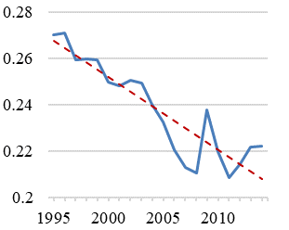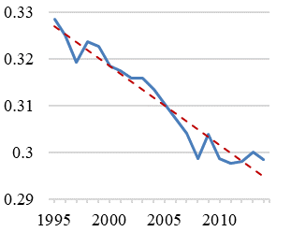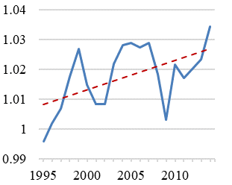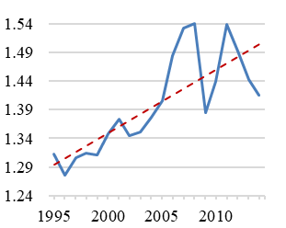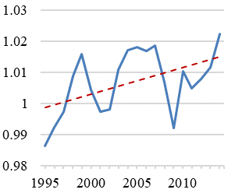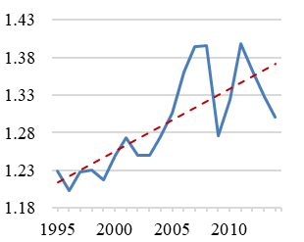

Labor output elasticity

Revenue labor share

Product market power

(rev. weights)

Labor market power

(rev. weights)

Product market power

(cost weights)

Labor market power

(cost weights)

Figure F.2 – Aggregates of firm-level labor shares, output elasticities of labor, product market power, and labor market power. Cost weights for product and labor market power parameters are respectively based on intermediate input expenditures and wage bills. Red dashed lines show linear trends. Germany’s manufacturing sector. Sample firms.

Within-firm vs. between-firm changes

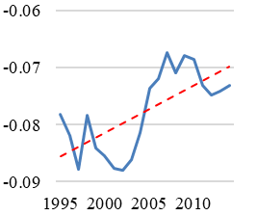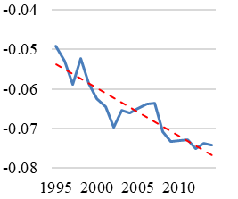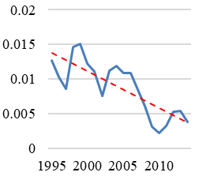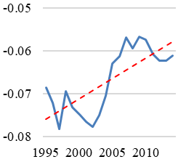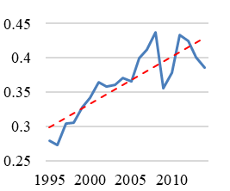

Revenue labor share

Labor output elasticity

Labor market power (rev. weights)

Product market power

(rev. weights)

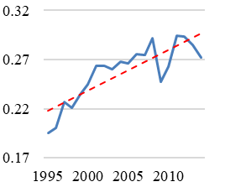

Product market power

(cost weights)

Labor market power (cost weights)

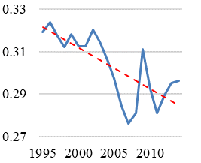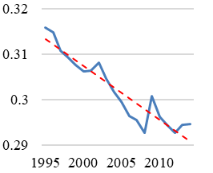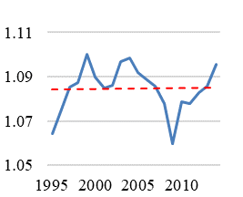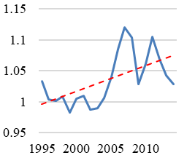

Revenue labor share

Product market power

Labor market power

Panel B: Between-firm changes

Panel A: Within-firm changes

Labor output elasticity

Figure F.3 – Aggregates of firm-level labor shares, output elasticities of labor, product market power, and labor market power. Within- and between-firm decomposition. Cost weights for product and labor market power parameters are respectively based on intermediate input expenditures and wage bills. Red dashed lines show linear trends. Germany’s manufacturing sector. Sample firm

Table F.1

|  |  |  |  |  |  |  |  |
| --- | --- | --- | --- | --- | --- | --- | --- |
| Relative changes in the aggregate labor share, labor output elasticity, and market power parameters, within- vs. between-firm changes | | | | | | | |
|  | Labor share | | |  | Output elasticity of labor | | |
| Period | $$∆{LS}_{jt}$$ (1) | Within  contribution  (2) | Between contribution  (3) |  | $${∆θ}_{jt}^{L}$$ (4) | Within  contribution  (5) | Between contribution  (6) |
| 1995-2000 | -7.50% | -2.58% | -4.92% |  | -3.07% | -2.91% | -0.16% |
| 2000-2005 | -7.00% | -5.98% | -1.02% |  | -2.50% | -2.09% | -0.41% |
| 2005-2010 | -5.54% | -2.10% | -3.45% |  | -3.84% | -1.06% | -2.78% |
| 2010-2014 | +1.10% | +1.62% | -0.52% |  | -0.02% | -0.54% | +0.52% |
| 1995-2014 | -17.85% | -8.59% | -9.25% |  | -9.14% | -6.43% | -2.71% |
|  | Product market power (rev. weights) | | |  | Labor market power (rev. weights) | | |
| Period | $$∆μ_{jt}$$ (7) | Within  contribution  (8) | Between contribution  (9) |  | $$∆γ_{jt}$$ (10) | Within  contribution  (11) | Between contribution  (12) |
| 1995-2000 | +1.91% | +2.54% | -0.63% |  | +2.64% | -2.10% | +4.74% |
| 2000-2005 | +1.37% | +0.19% | +1.17% |  | +4.28% | +2.58% | +1.70% |
| 2005-2010 | -0.71% | -1.25% | +0.54% |  | +2.38% | +1.48% | +0.89% |
| 2010-2014 | +1.26% | +1.64% | -0.37% |  | -1.65% | -2.24% | +0.59% |
| 1995-2014 | +3.87% | +3.13% | +0.74% |  | +7.77% | -0.32% | +8.09% |
| Product market power (cost weights) | | | |  | Labor market power (cost weights) | | |
| Period | $$∆μ_{jt}$$ (7) | Within  contribution  (8) | Between contribution  (9) |  | $$∆γ_{jt}$$ (10) | Within  contribution  (11) | Between contribution  (12) |
| 1995-2000 | +1.83% | +2.56% | -0.74% |  | +1.77% | -2.25% | +4.02% |
| 2000-2005 | +1.38% | +0.20% | +1.19% |  | +4.44% | +2.78% | +1.66% |
| 2005-2010 | -0.76% | -1.26% | +0.50% |  | +1.38% | +1.60% | -0.21% |
| 2010-2014 | +1.19% | +1.65% | -0.46% |  | -1.76% | -2.43% | +0.67% |
| 1995-2014 | +3.67% | +3.16% | +0.51% |  | +5.86% | -0.34% | +6.20% |
| Notes: Table F.1 documents the contribution of within- and between-firm changes to changes in the aggregates of labor shares, labor output elasticities, product market power, and labor market power, using different weights for aggregation. | | | | | | | |

#### Part 2: Changes in aggregate product and labor market power using firms’ full time equivalents as aggregation weights

Figure F.4 and F.5 respectively show aggregate values and between-firm terms for product and labor market power parameters using firms’ full time equivalents as weights for aggregation. The results are remarkably similar to the main text and the previous cost-weighted results in this online Appendix section. Again, large firms have particularly high labor market power and much of the increase in aggregate labor market power results from an increasing covariance between firm size and labor market power (i.e. from reallocation processes).

Aggregate product and labor market power, using firms’ full time equivalents as weights

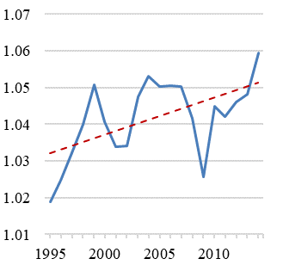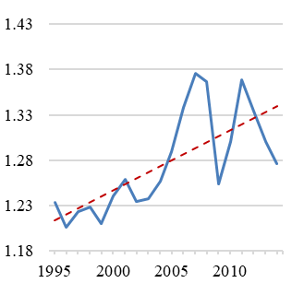

Product market power

(labor weights)

Labor market power

(labor weights)

Year

Figure F.4 – Aggregates of product market power and labor market power, using firms’ full time equivalents as aggregation weights. Red dashed lines show linear trends. Germany’s manufacturing sector. Sample firms.

Between-firm terms for product and labor market power, using firms’ full time equivalents as weights

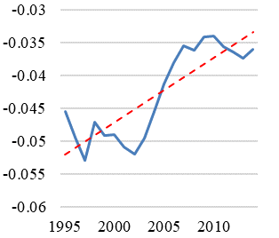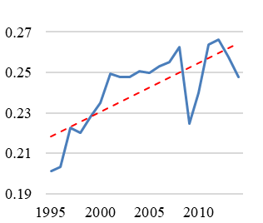

Product market power

(labor weights)

Labor market power (labor weight)

Year

Figure F.5 – Covariance between firms’ full time equivalents and product market power and labor market power. Red dashed lines show linear trends. Germany’s manufacturing sector. Sample firms.

#### Part 3: Changes in the value-added labor share and value-added output elasticity of labor and the contribution of market power to the falling value-added labor shares

Figure F.6 and F.7 show how the aggregate value-added labor share and the aggregate value-added output elasticity of labor changed over my observation period. To measure firms’ value-added output elasticity of labor, I use the approximation $θ_{it}^{L}κ_{it}=θ_{it}^{VAL}$, where $κ_{it}$ is the revenue over value-added ratio. To aggregate $θ_{it}^{VAL}$ and ${LS}_{it}^{VA}$, I use value-added weights. Recap that my measure of $θ_{it}^{VAL}$ is based on an approximation and only reliably measures the value-added output elasticity of labor if, *at the firm-level*, unit changes in labor lead to changes in gross output that are proportional to associated changes in value-added. Given this rather strict assumption, it is unsurprising that I find some extreme (and meaningless) values of $θ_{it}^{VAL}$, particularly in the right tails of $θ_{it}^{VAL}$ which are unbounded.[7] In some cases, firm-level value-added output elasticities imply that value-added labor shares under counterfactually competitive product and labor markets would be far beyond unity and that value-added returns to scale would be above 1.7. Therefore, results based on $θ_{it}^{VAL}$ should be treated with some caution.[8]

Aggregate value-added labor share and

aggregate value-added labor output elasticity

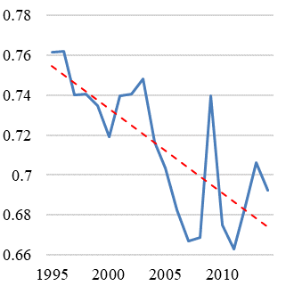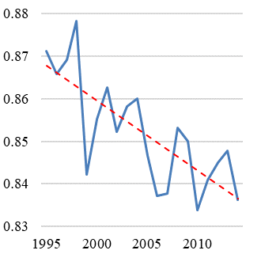

Value-added labor share

Value-added labor output elasticity

Year

Year

Figure F.6 – Aggregate value-added labor share and value-added output elasticity of labor. Red dashed lines show linear trends. Germany’s manufacturing sector. Sample firms.

The left Panel of Figure F.6 plots the decline of the value-added labor share from 0.76 to 0.69 which reflects a decline by 9% and which was also shown in Figure 1 of the main text. The right Panel of Figure F.6 displays a clear negative trend for the value-added labor output elasticity, which dropped by 3.5 percentage points from 0.871 to 0.836. This is consistent with the strong decrease in the gross output output elasticity of labor shown in the main text. Note that in terms of levels, $θ_{it}^{VAL}$ is much larger than the observed value-added labor share. This implies that already in 1995, the value-added labor share on counterfactually competitive factor and product markets had been roughly 11 percentage points higher, i.e. there is a huge negative effect on the value-added labor share from non-competitive factor and product markets. Again, recap, however, that one should treat estimates of $θ_{t}^{VAL}$ with caution, given that they are based on an approximation.

Figure F.7 presents within- and between-firm decompositions, which show a strong decline in the within-firm component of the value-added labor share. Overall, the within-firm component accounts for 5.3 percentage points of the 6.9 percentage point fall in the value-added labor share, implying that (within-firm) between-firm changes account for roughly (75%) 25% of the fall of the value-adbded labor share. For the value-added output elasticity of labor, I find an even stronger within-firm component that accounts for more than 90% of the fall of the value-added output elasticity of labor.

Figure F.8 subsequently shows the contribution of market power to the decline in labor’s share under the value-added concept, which I measure by:

|  |  |
| --- | --- |
| (F.1) | $$ψ_{t}^{VA}≡\left[\frac{\left(θ_{t=1995}^{VAL}-θ_{t}^{VAL}\right)}{θ_{t=1995}^{VAL}}-\frac{\left({LS}_{t=1995}^{VA}-{LS}_{t}^{VA}\right)}{{LS}_{t=1995}^{VA}}\right]*100.$$ |

As in the case of the revenue labor share, $ψ_{t}^{VA}$ declines over time, implying a positive contribution of market power to the fall of the value-added labor share. Overall, I find that rising market power can account for a 5% decline in the value-added labor share over the observation period (the value-added labor share declined by 9% in total). Similar to the revenue-based specification, this implies that 56% (44%) of the entire decline in the value-added labor share is accounted for by an increase (fall) in aggregate product and labor market power (in the aggregate value-added output elasticity of labor).

Note that differences in the contribution of rising market power and changing modes of production between the revenue and value-added labor share concept entirely result from changes in the aggregate value-added depth, $\frac{1}{κ_{t}}=\frac{{VA}_{t}}{P_{t}Q_{t}}$. Under constant $κ_{t}$, we would have $ψ_{t}^{VA}=ψ_{t}$ because $κ_{t}$ would cancel out in equation (8) and (F.1). Changes in $κ_{t}$ are exactly the reason why rescaling output elasticities from the gross output to the value-added concept does not perfectly work as such changes might reflect a change in the ratio of firms’ gross output marginal products of production factors to firms’ value-added marginal products of production factors. This in turn might indicate that intermediates are not used in fixed proportion to output. Nevertheless, it is reassuring that results on the contribution of market power and changing modes of production to the declining value-added labor share are similar to the corresponding results for the revenue labor share concept of the main text.

Finally, note that, again, there exists a close co-movement between aggregate firm labor market power and $ψ_{t}^{VA}$. Together with the comparably low estimates of product market power and the overall large contribution of market power to the decline of the value-added labor share, this implies a vital role for labor market power in contributing to the documented decline of the value-added labor share – as it is also the case for the revenue labor share.

Aggregate value-added labor share and

aggregate value-added labor output elasticity, within- vs. between-firm changes

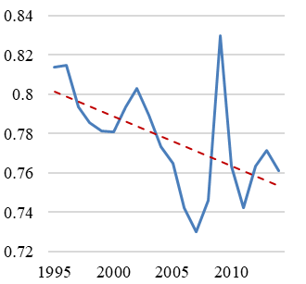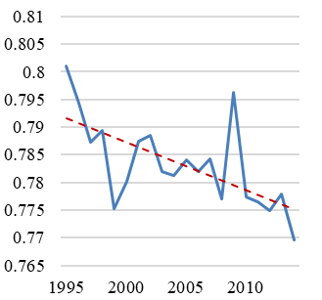

Value-added labor share

Value-added labor output elasticity

Panel A: Within-firm changes

Panel B: Between-firm changes

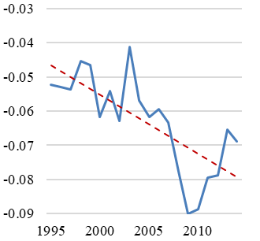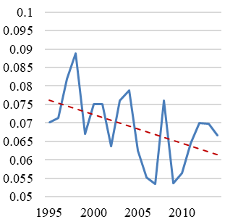

Value-added labor share

Value-added labor output elasticity

Year

Figure F.7 – Within- and between-firm changes for the aggregate value-added labor share and the aggregate value-added output elasticity of labor. Red dashed lines show linear trends. Germany’s manufacturing sector. Sample firms.

Figure F.8 – Aggregate labor market power and the contribution of market power to the decline in the value-added labor share. Germany’s manufacturing sector. Sample firms.

### Appendix F.2: Robustness check: Using a Cobb-Douglas production model

In this section, I replicate my main figures using two simple Cobb-Douglas production models that feature constant output elasticities of production factors. The first one is a production model where I assume that labor is a quasi-fixed input (as in the main text). The second one assumes that labor is fully flexible and jointly determined with firms’ intermediate input decision. Hence, in the latter case, labor is also no state variable of the firm (for a discussion see Ackerberg, Caves, & Frazer (2015)). Reproducing my results using these two models will show that my estimate on the increase of aggregate firm labor market power is not a particular feature of the specific production model I assume and that it instead reflects a fundamental change in the relation of labor expenditures to intermediate input expenditures in the data.

Both production models are based on the same production function specification and depart only in their identifying moments for the labor input and their control function for productivity. In both models, I apply the same firm-specific price correction techniques as in the main text, with the only difference that the price control function $B_{it}\left(.\right)$ now contains no interaction between production inputs and any other element of $B_{it}\left(.\right)$ (as I do not use the translog structure, see De Loecker, Goldberg, Khandelwal, & Pavcnik (2016)). The associated production function is:

|  |  |
| --- | --- |
| (F.1) | $$q_{it}={θ^{L}l}_{it}+{θ^{M}m}_{it}+{θ^{K}k}_{it}+B_{it}\left(.\right)+h_{it}\left(.\right)+ξ_{it}+ε_{it},$$ |

where $B_{it}\left(.\right)=B_{it}\left(π_{it}, {ms}_{it}, G_{it}, D_{it}\right)$. The notation follows the main text.

In case one, where labor is a quasi-fixed input, we have $h_{it}\left(.\right)=h_{it}\left(e_{it-1}, k_{it-1}, l_{it-1},{EX}_{it-1},{NumP}_{it-1},w_{it-1}\right)$, whereas in the second case, where labor is flexible and jointly determined with intermediates, we have $h_{it}\left(.\right)=h_{it}\left(e_{it-1}, k_{it-1},{EX}_{it-1},{NumP}_{it-1},w_{it-1}\right)$. As in the main text, I approximate $h_{it}\left(.\right)$ with a third order polynomial in $e_{it-1}$, $k_{it-1}$ and, if included, $l_{it-1}$ and add ${EX}_{it-1}$, ${NumP}_{it-1}$, and $w_{it-1}$ linearly.

For the first case, the identifying moments are based on variables that enter $h_{it}\left(.\right)$ as lagged values, lagged values of ${ms}_{it}$ and $π_{it}$, contemporary values of $G_{it}$ and $D_{it}$, contemporary values of $k_{it}$ and $l_{it}$, and the lagged value of $m_{it}$. I use the same identifying moments for the second model where labor is flexible, with exception for $l_{it}$, which I identify by its lagged value. Again, I identify the coefficients for each two-digit sector separately and control for a full set of time dummies in my estimation.

Below, I show changes over time for aggregated labor shares, market power parameters, and output elasticities of labor. Note that under industry-specific Cobb-Douglas production functions, changes in the aggregate output elasticity of labor are always a result of reallocation processes between industries or changes in the firm composition. Such changes are, however, small, which is in line with the main text’s finding that much of the decline in the baseline estimate of the output elasticity of labor is a within-firm phenomenon.

Below, Figures F.9 – F.14 present my results. In summary, I find for both Cobb-Douglas models:

* Minor increase in the aggregate output elasticity of labor.
* Higher and more strongly increasing firm labor market power than in the baseline specification. Most of this increase results from reallocation processes. High labor market power firms are large and gain increasingly large market shares.
* Low and slightly decreasing product market power levels.
* A close co-movement between the invers of the aggregate labor market power and the distortion parameter.
* Overall, the Cobb-Douglas models would imply that the entire fall in labor’s share results from increasing labor market power.

#### Results: Cobb-Douglas model with quasi-fixed labor

Revenue labor share and its components,

Cobb-Douglas specification with quasi-fixed labor

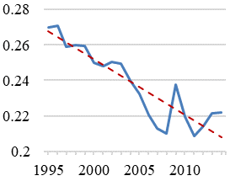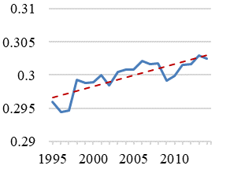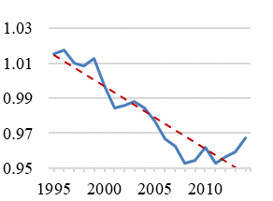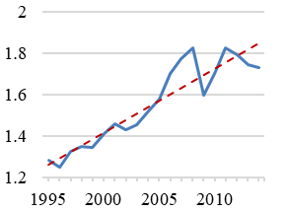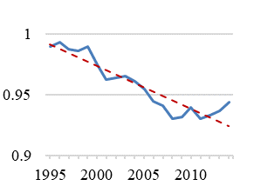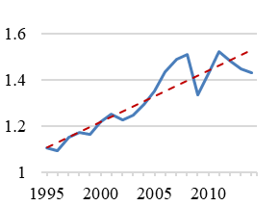

Labor output elasticity

Revenue labor share

Product market power

(rev. weights)

Labor market power

(rev. weights)

Product market power

(cost weights)

Labor market power

(cost weights)

Figure F.9 – Aggregates of firm-level labor shares, output elasticities of labor, product market power, and labor market power based on a Cobb-Douglas production function assuming quasi-fixed labor inputs. Cost weights for product and labor market power parameters are respectively based on intermediate input expenditures and wage bills. Red dashed lines show linear trends. Germany’s manufacturing sector. Sample firms.

Within- vs. between-firm changes,

Cobb-Douglas specification with quasi-fixed labor

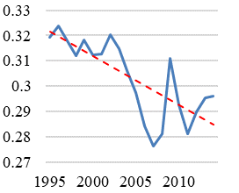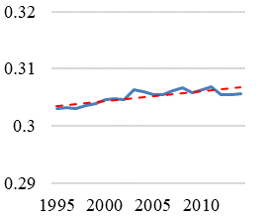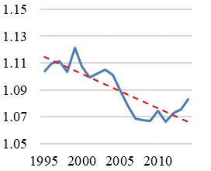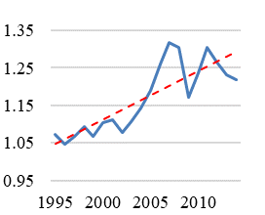

Revenue labor share

Labor output elasticity

Product market power

Labor market power

Panel A: Within-firm changes

Panel B: Between-firm changes

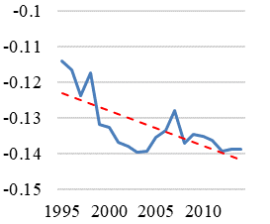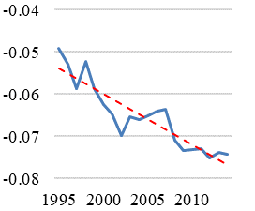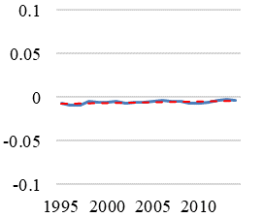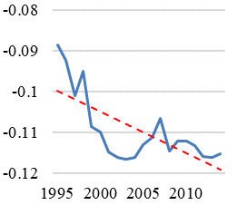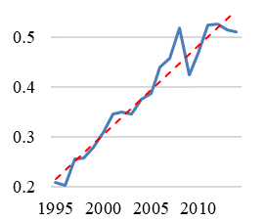

Revenue labor share

Labor output elasticity

Labor market power (rev. weights)

Product market power

(rev. weights)

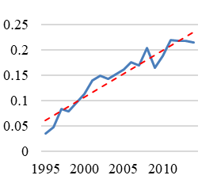

Product market power

(cost weights)

Labor market power (cost weights)

Figure F.10 – Aggregates of firm-level labor shares, output elasticities of labor, product market power, and labor market power. Within- and between-firm decomposition. Estimates based on a Cobb-Douglas production function assuming quasi-fixed labor inputs. Cost weights for product and labor market power parameters are respectively based on intermediate input expenditures and wage bills. Red dashed lines show linear trends. Germany’s manufacturing sector. Sample firms.

Figure F.11 – Aggregate labor market power and the contribution of market power to the decline in the revenue labor share. Estimates based on a Cobb-Douglas production function assuming quasi-fixed labor inputs Germany’s manufacturing sector. Sample firms.

#### Results: Cobb-Douglas model with flexible labor

Revenue labor share and its components,

Cobb-Douglas specification with flexible labor

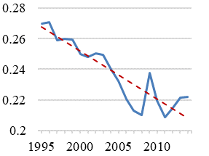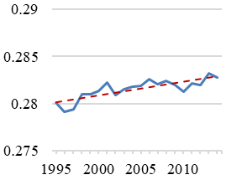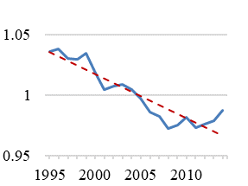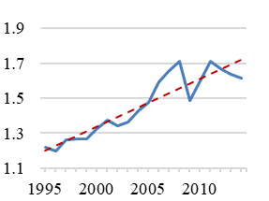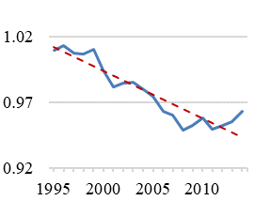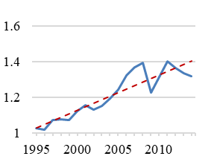

Labor output elasticity

Revenue labor share

Product market power

(rev. weights)

Labor market power

(rev. weights)

Product market power

(cost weights)

Labor market power

(cost weights)

Figure F.12 – Aggregates of firm-level labor shares, output elasticities of labor, product market power, and labor market power based on a Cobb-Douglas production function assuming flexible labor inputs. Cost weights for product and labor market power parameters are respectively based on intermediate input expenditures and wage bills. Red dashed lines show linear trends. Germany’s manufacturing sector. Sample firms.

Revenue labor share and its components,

Cobb-Douglas specification with flexible labor

Panel A: Within-firm changes

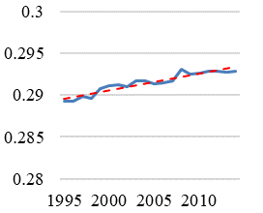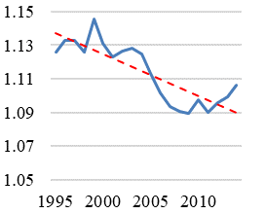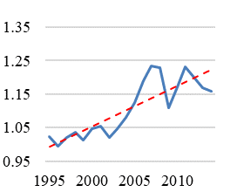

Revenue labor share

Labor output elasticity

Product market power

Labor market power

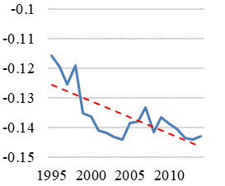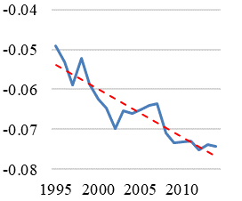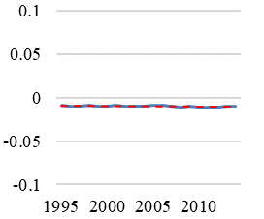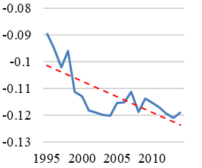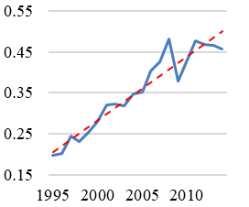

Revenue labor share

Labor output elasticity

Labor market power (rev. weights)

Product market power

(rev. weights)

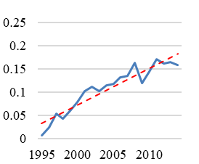

Product market power

(cost weights)

Labor market power (cost weights)

Panel B: Between-firm changes

Figure F.13 – Aggregates of firm-level labor shares, output elasticities of labor, product market power, and labor market power. Within- and between-firm decomposition. Estimates based on a Cobb-Douglas production function assuming flexible labor inputs. Cost weights for product and labor market power parameters are respectively based on intermediate input expenditures and wage bills. Red dashed lines show linear trends. Germany’s manufacturing sector. Sample firms.

Figure F.14 – Aggregate labor market power and the contribution of market power to the decline in the revenue labor share. Estimates based on a Cobb-Douglas production function assuming flexible labor inputs. Germany’s manufacturing sector. Sample firms.

### Appendix F.3: Robustness check: Time-varying Cobb-Douglas

This section replicates my findings using a time-varying and industry-specific Cobb-Douglas production function. This means, I estimate Cobb-Douglas production function coefficients for each year and industry separately, which is an alternative way to introduce time variation in output elasticities and which allows for a restricted version of factor-augmenting technological change.

This robustness check addresses concerns about the functional dependence of my baseline estimate of labor’s output elasticity on labor input levels. A result from this dependence could be a hard-wired link between movements in labor’s share and labor’s output elasticity. In contrast, estimates of output elasticities from a time-varying Cobb-Douglas production function are not subject to this functional form dependence. Hence, finding a decrease in the aggregate output elasticity of labor frobm this production model would constitute convincing evidence that the estimated changes in my baseline measure of labor’s output elasticity are valid.

The drawbacks of the time-varying Cobb-Douglas specification are that i) it does not yield firm-specific estimates of output elasticities and ii) it demands an enormous number of parameters to be estimated (as everything is interreacted with year dummies). Latter makes it impossible to employ the control function approaches of the main text to account for firm-specific input price variation and for the dependence of firms’ flexible inputs on productivity shocks. Hence, under a time-varying Cobb-Douglas, I must assume that there are no endogenous input decisions of firms. A violation of this condition would cause my production function estimates to be biased. To absorb at least some of the unobserved input price variation, I do, however, still control for location and four-digit industry dummies. The basic production function I estimate by OLS writes:

|  |  |
| --- | --- |
| (F.2) | $$q_{it}={θ_{t}^{L}l}_{it}+{θ_{t}^{M}m}_{it}+{θ_{t}^{K}k}_{it}+D_{it}+G_{it}+ω_{it}+ε_{it},$$ |

where parameters for $l_{it}$, $k_{it}$, and $m_{it}$ are estimated for each year separately by using a full interaction of these variables with a full set of year dummies. $D_{it}$ and $G_{it}$ respectively indicate an industry-dummy and a location-dummy. $ω_{it}$ is unobserved and, by assumption, uncorrelated with production inputs in this production model. Again, I estimate the production function separately for two-digit industries and control for a full set of time dummies in my estimation.

Below, Figures F.15 – F.17 present my results. In summary, I find:

* A smaller but decreasing aggregate output elasticity of labor, which fell from 0.263 to 0.241 between 1995 and 2014, while showing an upward movement in the latest years. Most of the decline results from within-firm changes.
* Decreasing product market power levels, implying no role of increasing product market power in contributing to the fall of labor’s share.
* Strongly increasing firm labor market power, mostly due to between-firm reallocation processes. High labor market power firms are large and gain increasingly large market shares.
* Changing production processes and increasing (labor) market power respectively explain 46% and 54% of the decline in the labor share.
* A close co-movement between the invers of the aggregate labor market power parameter and the distortion parameter.

Revenue labor share and its components,

time-varying Cobb-Douglas specification

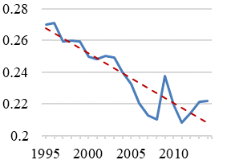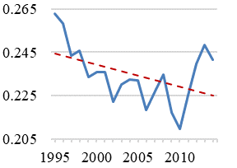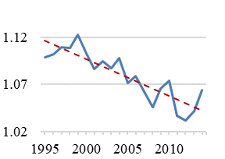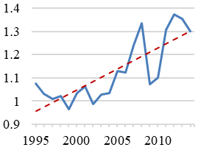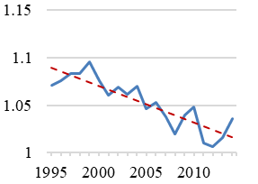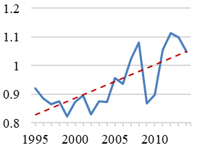

Labor output elasticity

Revenue labor share

Product market power

(rev. weights)

Labor market power

(rev. weights)

Product market power

(cost weights)

Labor market power

(cost weights)

Figure F.15 – Aggregates of firm-level labor shares, output elasticities of labor, product market power, and labor market power based on a time-varying Cobb-Douglas production function. Cost weights for product and labor market power parameters are respectively based on intermediate input expenditures and wage bills. Red dashed lines show linear trends. Germany’s manufacturing sector. Sample firms.

Within- vs. between-firm changes,

time-varying Cobb-Douglas specification

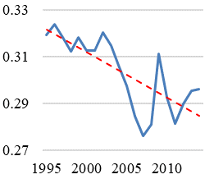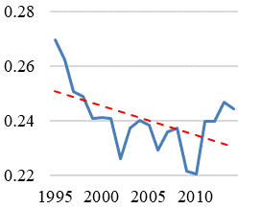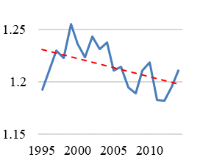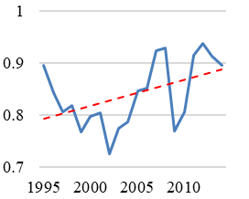

Revenue labor share

Labor output elasticity

Product market power

Labor market power

Panel A: Within-firm changes

Panel B: Between-firm changes

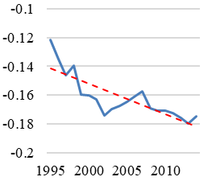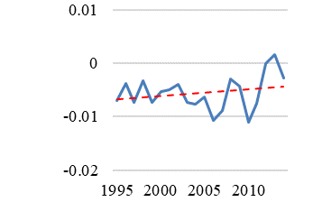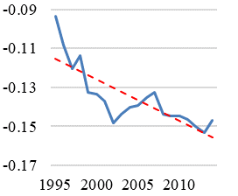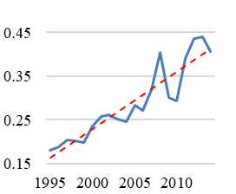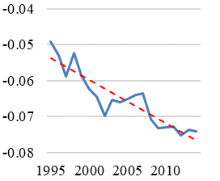

Revenue labor share

Labor output elasticity

Labor market power (rev. weights)

Product market power

(rev. weights)

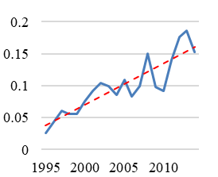

Product market power

(cost weights)

Labor market power (cost weights)

Figure F.16 – Aggregates of firm-level labor shares, output elasticities of labor, product market power, and labor market power. Within- and between-firm decomposition. Estimates based on a time-varying Cobb-Douglas production function. Cost weights for product and labor market power parameters are respectively based on intermediate input expenditures and wage bills. Red dashed lines show linear trends. Germany’s manufacturing sector. Sample firms.

Figure F.17 – Aggregate labor market power and the contribution of market power to the decline in the revenue labor share. Estimates based on a time-varying Cobb-Douglas model. Germany’s manufacturing sector. Sample firms.

### Appendix F.4: Robustness check: Flexible labor input

In my baseline specification, I estimate a production model that assumes that labor does not respond to productivity shocks, i.e. firms uncover the innovation in productivity after deciding on their labor inputs. Given the inflexibility of the German labor market, this assumption is justified.

To test the robustness of my estimates, however, this section estimates a translog production model assuming more flexible labor inputs while still allowing for dynamic implications of labor (similar to Ackerberg et al. (2015)). Given the inflexibility of the German labor market, allowing for dynamic implications of labor is important. The translog model is similar to the baseline specification with the minor difference that I apply a different approximation of the productivity control function $h_{it}\left(.\right)=h_{it}\left(e_{it-1}, k_{it-1}, l_{it-1},{EX}_{it-1},{NumP}_{it-1},w_{it-1}\right)$. In the baseline specification, I approximate $h_{it}\left(.\right)$ by a full third order polynomial in $e_{it-1}$, $k_{it-1}$, and $l_{it-1}$ while adding the remaining variables linearly. For the robustness test of this section, I use a third polynomial in $e_{it-1}$ and $k_{it-1}$ and add a cubic term of $l_{it-1}$ as well as an interaction term between $e_{it-1}$, $k_{it-1}$, and $l_{it-1}$. Again, I add ${EX}_{it-1}$, ${NumP}_{it-1}$, and $w_{it-1}$ linearly. I do so because assuming flexible labor inputs demands me to use lagged values of my translog production function terms that include labor as instruments for their contemporary counterparts. If I would include these lagged values also in the control function $h_{it}\left(.\right)$ as in the baseline specification of the main text, I would face an identification problem (Gandhi, Navarro, & Rivers (2020)). To still account for the dynamic implications of $l_{it-1}$, I include the cubic term in $l_{it-1}$ and the interaction term between $e_{it-1}$, $k_{it-1}$, and $l_{it-1}$ in my approximation of $h_{it}\left(.\right)$. Given that this is a reduced way of accounting for the dynamic implications of labor and given that I find results that are similar to my baseline estimates when using the production model of this section, I prefer my baseline specification.

Formally, the production model of this appendix section can be formulated as in the main text:

|  |  |
| --- | --- |
| (F.3) | $$q_{it}={\tilde{ϕ}}_{it}^{'}β+B_{it}\left(.\right)+h_{it}\left(.\right)+ξ_{it}+ε_{it},$$ |

while noting that I apply a different approximation of $h_{it}\left(.\right)$ as discussed above. Else, I follow the main text, including the definition of $B_{it}\left(.\right)$. I estimate (F.3) separately by two-digit industries and control for a full set of time dummies in my estimation. The identifying moments are based on lagged interactions of intermediate inputs with labor and capital, lagged interactions of labor with capital, contemporary values of capital and its higher order terms, contemporary location and industry dummies, the lagged output price index, lagged market shares, lagged elements of $h_{it}(.)$, and lagged interactions of the output price index with production inputs.

Below, Figures F.18 – F.20 present my results. In summary, I find:

* A larger and decreasing aggregate output elasticity of labor, which fell from 0.349 to 0.322 between 1995 and 2014, mostly due to within-firm changes.
* Low and slightly increasing product market power levels.
* High and strongly increasing firm labor market power, mostly due to a positive and increasing covariance between size and labor market power.
* Changing production processes and increasing market power respectively explain 43% and 57% of the decline in the labor share.
* A close co-movement between the invers of the aggregate labor market power parameter and the distortion parameter.

Revenue labor share and its components,

translog production function with flexible labor inputs

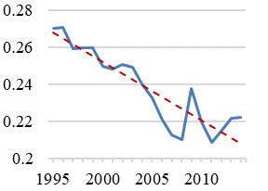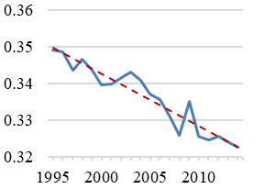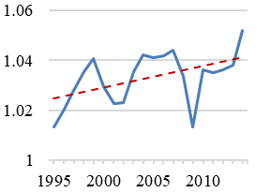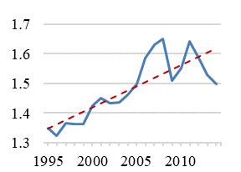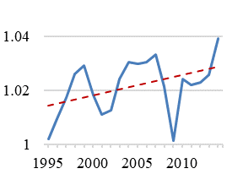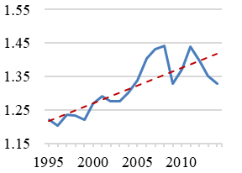

Labor output elasticity

Revenue labor share

Product market power

(rev. weights)

Labor market power

(rev. weights)

Product market power

(cost weights)

Labor market power

(cost weights)

Figure F.18 – Aggregates of firm-level labor shares, output elasticities of labor, product market power, and labor market power based on a translog production function allowing for flexible labor inputs. Cost weights for product and labor market power parameters are respectively based on intermediate input expenditures and wage bills. Red dashed lines show linear trends. Germany’s manufacturing sector. Sample firms.

Within- vs. between-firm changes,

translog production function with flexible labor inputs

Panel A: Within-firm changes

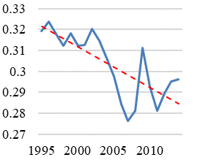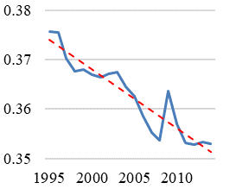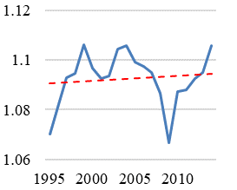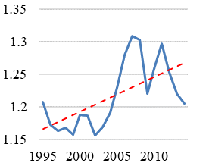

Revenue labor share

Labor output elasticity

Product market power

Labor market power

Panel B: Between-firm changes

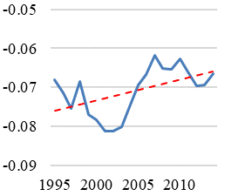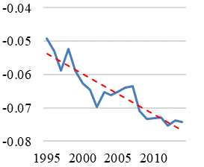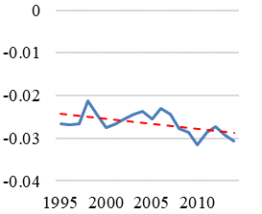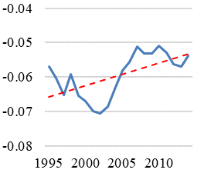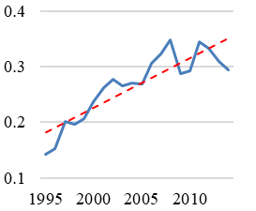

Revenue labor share

Labor output elasticity

Labor market power (rev. weights)

Product market power

(rev. weights)

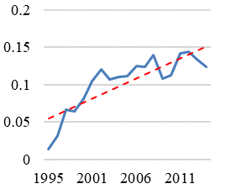

Product market power

(cost weights)

Labor market power (cost weights)

Figure F.19 – Aggregates of firm-level labor shares, output elasticities of labor, product market power, and labor market power. Within- and between-firm decomposition. Estimates based on a translog production function allowing for flexible labor inputs. Cost weights for product and labor market power parameters are respectively based on intermediate input expenditures and wage bills. Red dashed lines show linear trends. Germany’s manufacturing sector. Sample firms.

Figure F.20 – Aggregate labor market power and the contribution of market power to the decline in the revenue labor share. Estimates based on a translog production function with flexible labor inputs. Germany’s manufacturing sector. Sample firms.

### Appendix F.5: Robustness check: Omitting the firm-specific price correction

An important advantage of the German micro data applied in this study over other datasets is that it contains information on firm-specific product prices. From that, I can control for firm-specific input and output price variation in my estimation of the production function. Without controlling for firm-specific prices, my estimated output elasticities and, thus, my market power parameters are biased. Below, I show, however, that if I do not account for firm-specific price variation, I still find similar results with respect to *the changes* of my variables of interest over time. Nevertheless, as will become clear, accounting for firm-specific price variation is important (particularly for level estimates) and ignoring it underestimates the rise of (labor) market power the contribution of market power to the documented fall of labor’s share.

When ignoring firm-specific price variation, I do not deflate observed revenues with a firm-specific price deflator and instead use an industry-level deflator. This is also done in most other studies that do not have access to firm-specific price information. Moreover, I omit the price control function $B_{it}\left(.\right)$ and the average wage from $h_{it}\left(.\right)$. Hence, I estimate the following model:

|  |  |
| --- | --- |
| (F.4) | $${\tilde{r}}_{it}={\tilde{ϕ}}_{it}^{'}β+h_{it}\left(.\right)+ξ_{it}+ε_{it},$$ |

where ${\tilde{r}}_{it}$ denotes firm revenues deflated by an industry-level deflator that is supplied by the statistical office of Germany. Again, I estimate (F.4) separately by two-digit industries and control for a full set of year dummies in my regression. The identifying moments are identical to the main text, with the obvious exclusion for variables I omitted when not accounting for input-price variation.

Below, Figures F.18 – F.20 present my results. In summary, I find:

* A smaller but decreasing aggregate output elasticity of labor, which fell from 0.284 to 0.245 between 1995 and 2014, mostly due to within-firm changes.
* Slightly decreasing trend in product market power levels. Product market power levels are higher than in the baseline specification.
* Lower but increasing firm labor market power levels, mostly due to reallocation processes. High labor market power firms are large and gain increasingly large market shares.
* Changing production processes can explain roughly 78% of the decline in the labor share.
* A close co-movement between the invers of the aggregate labor market power parameter and the distortion parameter.

Revenue labor share and its components,

translog production function without firm-specific price correction

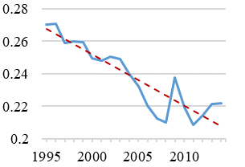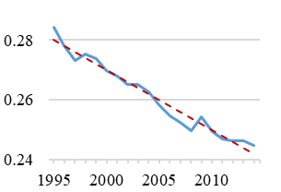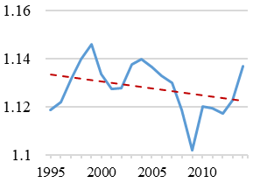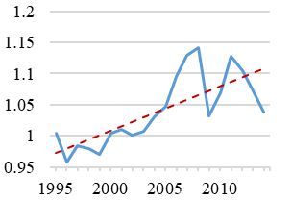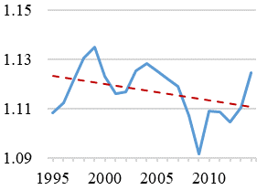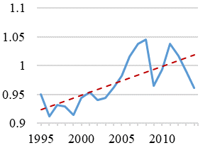

Labor output elasticity

Revenue labor share

Product market power

(rev. weights)

Labor market power

(rev. weights)

Product market power

(cost weights)

Labor market power

(cost weights)

Figure F.21 – Aggregates of firm-level labor shares, output elasticities of labor, product market power, and labor market power, based on a translog production function that does not account for firm-specific price variation. Cost weights for product and labor market power parameters are respectively based on intermediate input expenditures and wage bills. Red dashed lines show linear trends. Germany’s manufacturing sector. Sample firms.

Within- vs. between-firm changes,

translog production function without firm-specific price correction

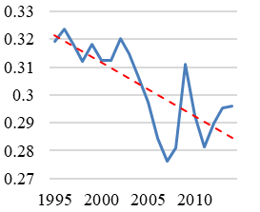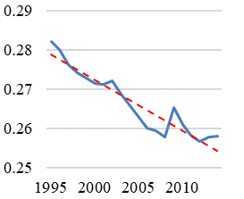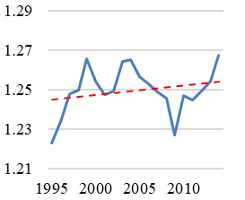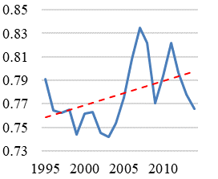

Revenue labor share

Labor output elasticity

Product market power

Labor market power

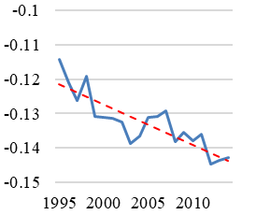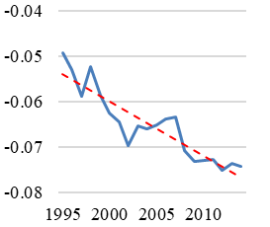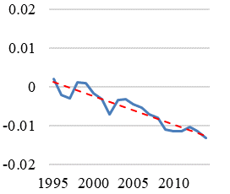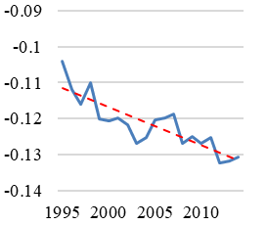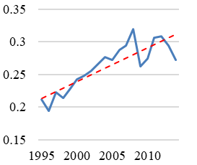

Revenue labor share

Labor output elasticity

Labor market power (rev. weights)

Product market power

(rev. weights)

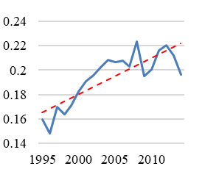

Product market power

(cost weights)

Labor market power (cost weights)

Panel A: Within-firm changes

Panel B: Between-firm changes

Figure F.22 – Aggregates of firm-level labor shares, output elasticities of labor, product market power, and labor market power. Within- and between-firm decomposition. Estimates based on a translog production function that does not account for firm-specific price variation. Cost weights for product and labor market power parameters are respectively based on intermediate input expenditures and wage bills. Red dashed lines show linear trends. Germany’s manufacturing sector. Sample firms.

Figure F.23 – Aggregate labor market power and the contribution of market power to the decline in the revenue labor share. Estimates based on a translog production function without firm-specific price correction. Germany’s manufacturing sector. Sample firms.

## Appendix G: Firm-product-level labor market power measures when having no information on product-/task-specific wages.

Here, I briefly show that, without having information on product-specific (or task-specific) wages, it is not meaningful to transfer my estimation of labor market power to the firm-product-level as in De Loecker et al. (2016). One can see this formally from the following equations:

Take the definition of labor market power:

|  |  |
| --- | --- |
| (G.1) | $$γ_{it}=\frac{θ_{it}^{L}}{θ_{it}^{M}}*\frac{z_{it}M_{it}}{w_{it}L_{it}}.$$ |

Now take the Econometrica paper by De Loecker et al. (2016). They show that a firm-product-level expression for product market power, $μ_{git}$, where $g$ indicates the product level, writes similar to the firm-level expression: $μ_{git}=θ_{git}^{M}*\frac{P_{git}Q_{git}}{ρ_{git}z_{it}M_{it}}$, where $ρ_{git}$ indicates the share of input expenditures allocated to product $g$ and $ρ_{git}z_{it}M_{it}$ denotes the intermediate input expenditures for product $g$. Importantly, to identify the input allocation term, $ρ_{git}$, in the framework of De Loecker et al. (2016), $ρ_{git}$ must be equal across *all* inputs of a firm (see De Loecker et al. (2016)).

Transferring (G.1) to the firm-product-level and substituting firm-specific input expenditures with their firm-product specific versions gives:

|  |  |
| --- | --- |
| (G.2) | $$γ_{git}=\frac{θ_{git}^{L}}{θ_{git}^{M}}*\frac{ρ_{git}z_{it}M_{it}}{ρ_{git}w_{it}L_{it}}=\frac{θ_{git}^{L}}{θ_{git}^{M}}*\frac{z_{it}M_{it}}{w_{it}L_{it}},$$ |

where I use $ρ_{git}z_{it}M_{it}$ and $ρ_{git}w_{it}L_{it}$ as a measure of firm-product-specific input expenditures because I do not directly observe firm-product or firm-task specific input expenditures.

Due to $ρ_{git}$ canceling out, all differences between $γ_{git}$ and $γ_{it}$ emerge from production technology differences across products (differences in $\frac{θ_{git}^{L}}{θ_{git}^{M}}$), if we do not have information on firm-product- (or task-) specific wages. This is not what we have in mind when discussing labor market power at the product/task level. Instead, we would like to have variation in labor market power across tasks resulting from different degrees of markdowns/bargaining power across tasks reflected in wedges between wages and marginal revenue products of labor that can vary between tasks due to task-specific wage and employment decisions of the firm.

## Appendix H: Mechanisms behind large and growing firm labor market power

This section provides suggestive evidence on potential drivers behind large and increasing firm labor market power. Table H.1 shows result from firm-level regressions projecting logs of firm-level labor market power parameters on observed firm characteristics (excluding dummies, all in logs), while controlling for industry and year fixed effects.

Table H.1

|  |  |  |  |
| --- | --- | --- | --- |
| Labor market power  and observed firm characteristics | | | |
|  | $γ_{it}$ (1) | $γ_{it}$ (2) | $$γ_{it}$$ (3) |
|  |  |  |  |
| Employment (FTE) | 0.189***  (0.0023) | 0.189***  (0.0023) | 0.114***  (0.0017) |
| East Germany (dummy) | 0.263***  (0.0057) | 0.263***  (0.0057) | 0.0533***  (0.0029) |
| Exporter (dummy) | 0.0720***  (0.0046) | 0.0693***  (0.0046) | -0.015***  (0.0025) |
| Industry-level sales concentration (HHI) |  | 0.0105***  (0.0026) | 0.0075***  (0.0016) |
| Capital over labor ratio |  |  | 0.129***  (0.0013) |
| Product market power |  |  | -2.311***  (0.0109) |
| Industry FE | YES | YES | YES |
| Time FE | YES | YES | YES |
| Observations | 212,159 | 212,159 | 212,159 |
| R-squared | 0.385 | 0.386 | 0.831 |
| Number of firms | 40,778 | 40,778 | 40,778 |
| Notes: Table H.1 reports results from correlating firm-level labor market power parameters with observed characteristics. Significance: *10 percent, **5 percent, ***1 percent. | | | |

Column 1 shows that firm size and export activity are both positively associated with firms’ labor market power, which is consistent with the main text’s finding that large firms have particularly high levels of labor market power. Also, firms located in East Germany are characterized by a higher level of labor market power, which is in line with existing work on German industrial relations showing that West Germany is characterized by a higher rate of collective wage agreements and a higher union density (Schnabel & Wagner (2007); Oberfichtner & Schnabel (2019)).[9] In column 2, I include am industry-level concentration measure into the regression, defined as the Hirschman-Herfindahl index (HHI) of sales concentration, which is an occupation based labor market concentration definition. I find that concentration is also positively associated with firms’ labor market power. Finally, column 3 adds firms’ capital over labor ratio and product market power to the regression. I find that firms being more capital intensive have higher labor market power. Firms’ product market power is negatively associated with their labor market power. Latter confirms the negative association between labor and product market power that is indicative of rent-sharing processes, as discussed in the main text. Notably, in column 4, the coefficient on the export dummy variable turns negative.

Table H.2

|  |  |  |  |  |  |
| --- | --- | --- | --- | --- | --- |
| Labor market power  and Industry-level concentration | | | | | |
|  | Revenue-weighted | |  | Cost-weighted | |
|  | $γ_{jt}$ (1) | $γ_{jt}$ (2) |  | $γ_{jt}$ (3) | $γ_{jt}$ (4) |
|  |  |  |  |  |  |
| Industry-level sales concentration (HHI) | 0.0215  (0.0164) | 0.0239  (0.0152) |  | 0.0344**  (0.0154) | 0.0367**  (0.0143) |
| Industry capital over labor ratio |  | 0.213***  (0.0449) |  |  | 0.207***  (0.0437) |
| Industry FE | YES | YES |  | YES | YES |
| Time FE | YES | YES |  | YES | YES |
| Observations | 4,635 | 4,635 |  | 4,635 | 4,635 |
| R-squared | 0.816 | 0.836 |  | 0.820 | 0.841 |
| Number of industries | 237 | 237 |  | 237 | 237 |
| Notes: Table H.2 reports results from correlating four-digit industry-level labor market power parameters with four-digit industry-level sales concentration indices. Column 1 and 2 use revenue-weighted industry-level aggregations of firm-level labor market power, while column 3 and 4 use cost-weighted industry-level aggregations of firm-level labor market power. Significance: *10 percent, **5 percent, ***1 percent. | | | | | |

Table H.2 shows four-digit industry-level regressions that regress logs of industry-level labor market power parameters on logs of industry-level sales concentration, measured by the HHI, while controlling for industry and year fixed effects. Hence, the coefficients in Table H.2 are identified from changes within industries.

Column 1 and 2 show results for sales-weighted aggregates of firm-level labor market power parameters, whereas column 3 and 4 use cost weights for aggregation. In both cases, I estimate a positive coefficient of industry sales concentration on industry labor market power. When using revenue weights, the coefficient is, however, only imprecisely estimated. In column 2 it is close to the 10-percent significance level. Using cost weights produces a larger coefficient that is statistically significant to the 5 percent level.

In Figure H.1, I investigate how four-digit industry-level concentration changed over my observation period. To do so, I regress logs of industry-level sales concentration on a full set of time and industry dummies. Figure H.1 plots the coefficients of the year dummies. As can be seen, there is a clear positive trend in industry-level concentration in the German manufacturing sector.

Figure H.1 – Changes in four-digit industry-level sales concentration, defined by the industry-level Hirschman-Herfindahl index. Red dashed lines show linear trends. Germany’s manufacturing sector. Sample firms.

Figures H.2 and H.3 also shows how four-digit industry-level labor market power changed by plotting regression coefficients on time dummies from a regression of log industry-level labor market power on a full set of time and industry dummies (as in Figure H.1). As can be seen, although the individual coefficients, particularly in the early years, are not always statistically significant, there is a clear positive trend in industry-level labor market power.

Figure H.2 – Changes in four-digit industry-level labor market power, using sales-weighted aggregates of firm-level labor market power. Red dashed lines show linear trends. Germany’s manufacturing sector. Sample firms.

Figure H.3 – Changes in four-digit industry-level labor market power, using cost-weighted aggregates of firm-level labor market power. Red dashed lines show linear trends. Germany’s manufacturing sector. Sample firms.

In addition to the results presented here, Mertens (2020) shows that export market profit gains in Germany are not fully shared with workers, which raises firms’ labor market power. Using a similar approach, Dobbelaere, Hirsch, Müller, & Neuschäffer (2020) show that the existence of work councils and union wage agreements in Germany are negatively associated with firm labor market power. Latter is also in line with results in Table H.1 indicating that firms located in East Germany, which is historically characterized by a lower union density than West Germany, possess higher labor market power levels. Together, my results and the existing evidence in the literature suggest that wedges between wages and marginal revenue products are indeed informative about firms’ total labor market power (which is a combination of firms’ workforce bargaining power and firms’ monopsony power, see Appendix B.2). As noted in the main text, a large labor market literature also relies exactly on such wedges to define labor market power (see for instance Dobbelaere & Mairesse (2013) and the literature cited therein).

## Appendix I: Decomposition of aggregate labor share changes in Germany

In this section I show that the fall of the economy-wide labor share in Germany is mostly a result of falling labor shares within one-digit sectors. This gives a sense on the relatively small importance of cross-sectoral reallocation processes in explaining falling economy-wide labor shares. While in this article I focus on the manufacturing sector to exploit my unique firm-product-level data and to study potential mechanisms driving changes in labor’s share, the exercise in this section highlights that understanding patterns within individual one-digit sectors, such as manufacturing, is important for understanding the economy-wide decline in labor’s share.

To decompose changes in the economy-wide labor share into within- and between-sector changes, I use official data from the federal statistical office of Germany that contain information on wages, value-added, and gross output for 20 different one-digit-sectors according to NACE rev. 2. Table I.1 shows a list of these sectors.

Table I.1

|  |  |
| --- | --- |
| NACE rev. 2 one-digit-sectors | |
| A | Agriculture, forestry, and fishing |
| B | Mining and quarrying |
| C | Manufacturing |
| D | Electricity, gas, steam, and aid conditioning supply |
| E | Water supply, sewerage, wage management, and remediation activities |
| F | Construction |
| G | Wholesale and retail trade, repair of motor vehicles and motorcycles |
| H | Transportation and storage |
| I | Accommodation and food service activities |
| J | Information and communication |
| K | Financial and insurance activities |
| L | Real estate activities |
| M | Professional, scientific, and technical activities |
| N | Administrative and support service activities |
| O | Public administration and defense, compulsory social security |
| P | Education |
| Q | Human heal and social work activities |
| R | Arts, entertainment, and recreation |
| S | Other service activities |
| T | Private households |
| Notes: Table I.1 lists the one-digit-sector for which I run Olley-Pakes (1996) decompositions in Table I.2. | |

Using the same decomposition as in the main text, Table I.2 shows within- and between-sector changes for the economy-wide revenue and value-added labor share over selected periods. For every variable, the first column reports the relative change in its aggregate value, while the second and third columns show the within- and between-firm contribution to the total change. As Table I.2 shows, between 1995 and 2014 within-one-digit-sector (between-one-digit-sector) changes account for 86.5 (14.5) percent and 76.0 (24.0) percent of the decline in the economy-wide revenue and value-added labor share, respectively.

Hence, irrespective of the labor share concept, most of the economy-wide decline in labor’s share indeed results from within-one-digit-sector changes.

Table I.2

|  |  |  |  |  |  |  |  |
| --- | --- | --- | --- | --- | --- | --- | --- |
| Relative changes in the economy-wide revenue and value-added labor share, within- vs. between-firm changes | | | | | | | |
|  | Revenue labor share | | |  | Value-added labor share | | |
| Period | Change revenue LS  (1) | Within  contribution  (2) | Between contribution  (3) |  | Change value-added LS  (4) | Within  contribution  (5) | Between contribution  (6) |
| 1995-2000 | -6.83% | -4.66% | -2.17% |  | -0.02% | +3.30% | -3.32% |
| 2000-2005 | -8.63% | -8.65% | +0.02% |  | -5.62% | -5.00% | -0.62% |
| 2005-2010 | -4.46% | -4.10% | -0.37% |  | +0.91% | -2.40% | +3.31% |
| 2010-2014 | +1.32% | +1.21% | +0.11% |  | +1.57% | +1.54% | +0.03% |
| 1995-2014 | -17.60% | -15.22% | -2.38% |  | -3.29% | -2.50% | -0.78% |
| Notes: Table I.2 documents the contribution of within- and between-one-digit-sector changes to changes in the aggregate revenue and value-added labor share. | | | | | | | |

## Appendix J: Labor shares, output elasticities of labor, and product and labor market power for firms of different size

Table J.1 classifies firms into four size classes in terms of employment full time equivalents (below 50, 51-100, 101-250, and above 250) and studies how average (not aggregate) labor shares, market power parameters, output elasticities of labor, and sales and employment shares changed over my observation period for these size classes. This provides more insights on how these variables differ between firms of different size, which is important for understanding how the documented aggregate patterns emerge.

Note first that Panel A shows that the largest firms account by far for most of economic activity. In 1995 the sales (employment) share of firms with more than 250 full time equivalents is 74 (70) percent. Whereas the revenue share of the largest firms grows by 3 percentage points from 1995 to 2014, their employment share stays constant. Nevertheless, there is also reallocation of employment from the smallest to larger firms over time. This is consistent with reallocation patterns documented in the US, highlighting an increase in market shares of large firms over the past decades (e.g. Autor et al. (2020)).

Consistent with the covariance terms of the main text and online Appendix F, panel B and C show that larger firms have lower labor shares, higher output elasticities, lower product market power, and higher labor market power. Particularly labor market power is strongly rising with firm size.

Average labor shares and labor output elasticities declined most in the largest two firm groups. Product market power rose equally across all firm groups, whereas labor market power only rose for the largest firm group by 0.04 points. The latter is much lower than the aggregate increase in labor market power (from 1.31 to 1.42). Recap however that the rise in aggregate labor market power is mainly a result of an increase in the covariance between labor market power and firm size. When I compute the decomposition exercise of the main text into within- and between-firm changes, I find that, even within size-classes, there is a significant increase in the covariance term. Hence, also within size classes, higher aggregate labor market power is driven by a larger concentration of market shares in high/increasing labor market power firms. Table J.2 and J.3 respectively show changes in the associated covariance terms and aggregate indicators (the sum of values in Table J.1 and J.2 equal the values in Table J.3 with some rounding errors).

Notably, *smaller* aggregate (Table J.3) and average markups (Table J.1) together with *larger* average and aggregate labor market power for the largest firms could suggest that large German manufacturing firms can be active in competitive product markets while still being profitable due to their high labor market power. In that sense there might be strategic interactions between labor and product market power that, for instance, could allow firms to conquer new markets without becoming too unprofitable. This is also consistent with i) the literature’s finding that product markups are in several datasets lower in larger firms (see Caselli et al. (2019)) and ii) the negative correlation between product and labor market power documented in the main text.[10] Yet, analyzing these interactions goes beyond the scope of this study.

Overall, the findings of this appendix section highlight a key role of large firms in driving the decline of the labor share. Large firms show the strongest decline in labor’s share and have the lowest labor share level. Simultaneously, economic activity reallocates towards large firms. Moreover, as labor market power is particularly high in large firms, policy measures to reduce labor market power must consider the key role of large firms (see section 4.4 of the main text for discussion). Tables J.4, J.5, J.6 show that these results are also holding when defining firm size in terms of quartiles of the revenue distribution, although some patterns are less pronounced due to the revenue distribution being characterized by a much longer right tail.

Table J.1

|  |  |  |  |  |  |  |  |
| --- | --- | --- | --- | --- | --- | --- | --- |
| Changes in average labor shares, labor output elasticities, and market power parameters, by firm size class | | | | | | | |
| Panel A | Sales share | | |  | Employment (FTE) share | | |
| Size class employees (FTE) | 1995 | 2014 | Change |  | 1995 | 2014 | Change |
| $≤$ 50 | 0.03 | 0.02 | -0.01 |  | 0.05 | 0.04 | -0.01 |
| 51-100 | 0.06 | 0.05 | -0.01 |  | 0.08 | 0.08 | +0.00 |
| 101-250 | 0.15 | 0.14 | -0.01 |  | 0.17 | 0.18 | +0.01 |
| $>$ 250 | 0.75 | 0.78 | +0.03 |  | 0.70 | 0.70 | +0.00 |
| Panel B | Average labor share | | |  | Average output elasticity of labor | | |
| Size class employees (FTE) | 1995 | 2014 | Change |  | 1995 | 2014 | Change |
| $≤$ 50 | 0.33 | 0.32 | -0.01 |  | 0.27 | 0.26 | -0.01 |
| 51-100 | 0.32 | 0.31 | -0.01 |  | 0.30 | 0.29 | -0.01 |
| 101-250 | 0.32 | 0.28 | -0.04 |  | 0.34 | 0.30 | -0.04 |
| $>$ 250 | 0.30 | 0.27 | -0.03 |  | 0.37 | 0.34 | -0.03 |
| Panel C | Average labor market power | | |  | Average product market power | | |
| Size class employees (FTE) | 1995 | 2014 | Change |  | 1995 | 2014 | Change |
| $≤$ 50 | 0.83 | 0.79 | -0.04 |  | 1.09 | 1.12 | +0.02 |
| 51-100 | 0.98 | 0.92 | -0.06 |  | 1.07 | 1.11 | +0.04 |
| 101-250 | 1.12 | 1.11 | -0.01 |  | 1.06 | 1.09 | +0.03 |
| $>$ 250 | 1.30 | 1.34 | +0.04 |  | 1.03 | 1.06 | +0.03 |
| Notes: Table J.1 documents changes in market shares (Panel A), average labor shares (Panel B), labor output elasticities (Panel B), product market power (Panel C), and labor market power (Panel C) by firm size classes. | | | | | | | |

Table J.2

|  |  |  |  |  |  |  |  |
| --- | --- | --- | --- | --- | --- | --- | --- |
| Changes in covariance terms between firm size (sales) and labor shares, labor output elasticities, and market power parameters, by firm size class | | | | | | | |
|  | Covariance firm sales and labor shares | | |  | Covariance firm sales and labor output elasticities | | |
| Size class employees (FTE) | 1995 | 2014 | Change |  | 1995 | 2014 | Change |
| $≤$ 50 | -0.05 | -0.05 | +0.00 |  | -0.02 | -0.02 | +0.00 |
| 51-100 | -0.05 | -0.05 | +0.00 |  | -0.03 | -0.03 | +0.00 |
| 101-250 | -0.05 | -0.06 | -0.01 |  | -0.03 | -0.03 | +0.00 |
| $>$ 250 | -0.03 | -0.05 | -0.02 |  | -0.03 | -0.03 | +0.00 |
|  | Covariance firm sales and labor market power | | |  | Covariance firm sales and product market power | | |
| Size class employees (FTE) | 1995 | 2014 | Change |  | 1995 | 2014 | Change |
| $≤$ 50 | 0.09 | 0.11 | +0.02 |  | -0.03 | -0.03 | +0.00 |
| 51-100 | 0.09 | 0.13 | +0.04 |  | -0.02 | -0.03 | -0.01 |
| 101-250 | 0.10 | 0.19 | +0.08 |  | -0.02 | -0.03 | -0.01 |
| $>$ 250 | 0.07 | 0.13 | +0.06 |  | -0.05 | -0.04 | +0.01 |
| Notes: Table J.2 documents changes in covariance terms between firms’ market shares (sales) and firms’ labor shares, labor output elasticities, product market power, and labor market power by firm size classes. | | | | | | | |

Table J.3

|  |  |  |  |  |  |  |  |
| --- | --- | --- | --- | --- | --- | --- | --- |
| Changes in aggregate labor shares, labor output elasticities, and market power parameters, by firm size class | | | | | | | |
|  | Aggregate labor share (sales-weighted) | | |  | Aggregate labor output elasticities (sales-weighted) | | |
| Size class employees (FTE) | 1995 | 2014 | Change |  | 1995 | 2014 | Change |
| $≤$ 50 | 0.28 | 0.27 | -0.01 |  | 0.25 | 0.23 | -0.02 |
| 51-100 | 0.27 | 0.25 | -0.02 |  | 0.27 | 0.26 | -0.01 |
| 101-250 | 0.27 | 0.23 | -0.04 |  | 0.31 | 0.27 | -0.04 |
| $>$ 250 | 0.27 | 0.22 | -0.05 |  | 0.34 | 0.31 | -0.03 |
|  | Aggregate labor market power (sales-weighted) | | |  | Aggregate product market power (sales-weighted) | | |
| Size class employees (FTE) | 1995 | 2014 | Change |  | 1995 | 2014 | Change |
| $≤$ 50 | 0.92 | 0.90 | -0.02 |  | 1.06 | 1.09 | +0.03 |
| 51-100 | 1.06 | 1.05 | -0.01 |  | 1.05 | 1.09 | +0.04 |
| 101-250 | 1.22 | 1.30 | +0.08 |  | 1.03 | 1.03 | +0.03 |
| $>$ 250 | 1.37 | 1.48 | +0.11 |  | 0.98 | 1.02 | +0.04 |
| Notes: Table J.3 documents changes aggregate labor shares, labor output elasticities, product market power, and labor market power (all sales-weighted) by firm size classes. | | | | | | | |

Table J.4

|  |  |  |  |  |  |  |  |
| --- | --- | --- | --- | --- | --- | --- | --- |
| Changes in average labor shares, labor output elasticities, and market power parameters, by firm sales quartiles | | | | | | | |
| Panel A | Sales share | | |  | Employment (FTE) share | | |
| Firm sales quartiles | 1995 | 2014 | Change |  | 1995 | 2014 | Change |
| 1st quartile | 0.02 | 0.02 | +0.00 |  | 0.04 | 0.05 | +0.01 |
| 2nd quartile | 0.05 | 0.04 | -0.01 |  | 0.08 | 0.08 | +0.00 |
| 3rd quartile | 0.12 | 0.11 | -0.01 |  | 0.15 | 0.16 | +0.01 |
| 4th quartile | 0.81 | 0.84 | +0.03 |  | 0.73 | 0.71 | -0.02 |
| Panel B | Average labor share | | |  | Average output elasticity of labor | | |
| Firm sales quartiles | 1995 | 2014 | Change |  | 1995 | 2014 | Change |
| 1st quartile | 0.39 | 0.37 | -0.02 |  | 0.30 | 0.29 | -0.01 |
| 2nd quartile | 0.32 | 0.31 | -0.01 |  | 0.30 | 0.29 | -0.01 |
| 3rd quartile | 0.30 | 0.27 | -0.03 |  | 0.32 | 0.29 | -0.03 |
| 4th quartile | 0.27 | 0.23 | -0.04 |  | 0.34 | 0.31 | -0.03 |
| Panel C | Average labor market power | | |  | Average product market power | | |
| Firm sales quartiles | 1995 | 2014 | Change |  | 1995 | 2014 | Change |
| 1st quartile | 0.76 | 0.72 | -0.04 |  | 1.12 | 1.14 | +0.02 |
| 2nd quartile | 0.93 | 0.89 | -0.04 |  | 1.07 | 1.11 | +0.04 |
| 3rd quartile | 1.10 | 1.08 | -0.02 |  | 1.05 | 1.08 | +0.03 |
| 4th quartile | 1.34 | 1.42 | +0.12 |  | 1.02 | 1.05 | +0.03 |
| Notes: Table J.4 documents changes in market shares (Panel A), average labor shares (Panel B), labor output elasticities (Panel B), product market power (Panel C), and labor market power (Panel C) by firm revenue quartiles. | | | | | | | |

Table J.5

|  |  |  |  |  |  |  |  |
| --- | --- | --- | --- | --- | --- | --- | --- |
| Changes in covariance terms between firm size (sales) and labor shares, labor output elasticities, and market power parameters, by firm sales quartiles | | | | | | | |
|  | Covariance firm sales and labor shares | | |  | Covariance firm sales and labor output elasticities | | |
| Firm sales quartiles | 1995 | 2014 | Change |  | 1995 | 2014 | Change |
| 1st quartile | -0.01 | -0.01 | +0.00 |  | +0.00 | +0.00 | +0.00 |
| 2nd quartile | +0.00 | +0.00 | +0.00 |  | +0.00 | +0.00 | +0.00 |
| 3rd quartile | +0.00 | +0.00 | +0.00 |  | +0.00 | +0.00 | +0.00 |
| 4th quartile | -0.01 | -0.02 | -0.01 |  | -0.01 | -0.01 | +0.00 |
|  | Covariance firm sales and labor market power | | |  | Covariance firm sales and product market power | | |
| Firm sales quartiles | 1995 | 2014 | Change |  | 1995 | 2014 | Change |
| 1st quartile | 0.01 | 0.01 | +0.00 |  | -0.01 | -0.01 | +0.00 |
| 2nd quartile | 0.01 | 0.01 | +0.00 |  | +0.00 | +0.00 | +0.00 |
| 3rd quartile | 0.01 | 0.02 | +0.01 |  | +0.00 | +0.00 | +0.00 |
| 4th quartile | 0.04 | 0.07 | +0.03 |  | -0.05 | -0.03 | +0.01 |
| Notes: Table J.5 documents changes in covariance terms between firms’ market shares (sales) and firms’ labor shares, labor output elasticities, product market power, and labor market power by firm revenue quartiles. | | | | | | | |

Table J.6

|  |  |  |  |  |  |  |  |
| --- | --- | --- | --- | --- | --- | --- | --- |
| Changes in aggregate labor shares, labor output elasticities, and market power parameters, by firm sales quartiles | | | | | | | |
|  | Aggregate labor share (sales-weighted) | | |  | Aggregate labor output elasticities (sales-weighted) | | |
| Firm sales quartiles | 1995 | 2014 | Change |  | 1995 | 2014 | Change |
| 1st quartile | 0.28 | 0.27 | -0.01 |  | 0.30 | 0.29 | -0.01 |
| 2nd quartile | 0.27 | 0.25 | -0.02 |  | 0.30 | 0.29 | -0.01 |
| 3rd quartile | 0.27 | 0.23 | -0.04 |  | 0.32 | 0.29 | -0.03 |
| 4th quartile | 0.27 | 0.22 | -0.05 |  | 0.33 | 0.30 | -0.03 |
|  | Aggregate labor market power (sales-weighted) | | |  | Aggregate product market power (sales-weighted) | | |
| Firm sales quartiles | 1995 | 2014 | Change |  | 1995 | 2014 | Change |
| 1st quartile | 0.78 | 0.74 | -0.04 |  | 1.11 | 1.14 | +0.03 |
| 2nd quartile | 0.94 | 0.90 | -0.04 |  | 1.07 | 1.11 | +0.04 |
| 3rd quartile | 1.11 | 1.11 | +0.00 |  | 1.05 | 1.08 | +0.03 |
| 4th quartile | 1.38 | 1.49 | +0.11 |  | 0.98 | 1.02 | +0.04 |
| Notes: Table J.6 documents changes aggregate labor shares, labor output elasticities, product market power, and labor market power (all sales-weighted) by firm revenue quartiles. | | | | | | | |

## Appendix K: Industry-level within- and between-firm changes

Tables K.1 shows changes in industry-level aggregate labor shares, labor output elasticities, firm labor market power, and firm product market power. Consistent with results in Table 3 of the main text and online Appendix D, industry-level labor shares and labor output elasticities declined in almost all industries. Firm product market power increased in almost all industries, while industry-level changes in labor market power are more mixed (11 out of 20 industries show an increase), which is in line with the result that two thirds of the aggregate increase in labor market power are driven by between-two-digit-industry reallocation processes. Interestingly, only the food products and beverages industry shows an aggregate labor market power parameter smaller than one, implying that workers have a rather strong labor market position in this industry. This results from the low labor output elasticity (0.15 in 2014) in this sector that would imply an even lower labor share than already observed (0.17 in 2014).

By 2014, industry-level firm labor market power is highest in the wood and wood products industry and in the manufacturing of basic metals. Again, this is explained by a large discrepancy between the output elasticity of labor (much higher) and the labor share (much lower).

Table K.2 shows the within-between-firm decomposition of the main text for each two-digit industry separately. There is a large heterogeneity across industries in the importance of between- and within-firm dynamics in driving industry-level changes in labor shares and their drivers. For the labor share decomposition, within-firm contributions to declining labor shares are larger than between-firm contributions in 13 out of 20 industries, highlighting a particular importance of the within-firm components for explaining declining industry-level labor shares. For output elasticities the picture is similar. 12 out of 20 industries show a larger importance for the within-firm component (i.e. a smaller within-firm component). For product market power I find that the within-firm component is larger in 13 out of 20 industries, suggesting a larger importance of the within-firm term for the increase in product market power observed in most industries. For labor market power, the within-firm component is larger than the between-firm component in only in 7 out of 20 industries. This is consistent with the overall picture that between-firm dynamics are particularly important to explain the rise manufacturing-wide firm labor market power.

Table K.1

|  |  |  |  |  |
| --- | --- | --- | --- | --- |
| Changes in industry-level labor shares, labor output elasticities and labor and product market power parameters (1995-2014) | | | | |
| Sector | Change in the labor share  (1) | Change in the output elasticity of labor  (2) | Change in labor market power  (3) | Change in product market power  (4) |
| 15 Food products and beverages | 0.18 to 0.17 (-0.01) | 0.17 to 0.15 (-0.02) | 0.98 to 0.89 (-0.09) | 1.01 to 1.01 (+0.00) |
| 17 Textiles | 0.25 to 0.22 (-0.04) | 0.32 to 0.28 (-0.04) | 1.32 to 1.21 (-0.11) | 1.03 to 1.08 (+0.05) |
| 18 Apparel, dressing, and dyeing of fur | 0.22 to 0.23 (+0.01) | 0.25 to 0.26 (+0.01) | 1.18 to 1.03 (-0.05) | 1.04 to 1.11 (+0.07) |
| 19 Leather and leather products | 0.25 to 0.23 (-0.02) | 0.28 to 0.25 (-0.03) | 1.15 to 1.02 (-0.13) | 1.02 to 1.03 (+0.01) |
| 20 Wood and wood products | 0.24 to 0.16 (-0.08) | 0.36 to 0.27 (-0.09) | 1.78 to 2.19 (+0.41) | 0.91 to 0.90 (-0.01) |
| 21 Pulp, paper, and paper products | 0.21 to 0.19 (-0.02) | 0.33 to 0.28 (-0.05) | 1.77 to 1.58 (-0.19) | 0.94 to 1.00 (+0.06) |
| 22 Publishing and printing | 0.31 to 0.26 (-0.05) | 0.33 to 0.27 (-0.06) | 1.22 to 1.23 (+0.01) | 0.98 to 0.97 (-0.01) |
| 24 Chemicals and chemical products | 0.26 to 0.18 (-0.08) | 0.24 to 0.20 (-0.04) | 1.02 to 1.20 (-0.18) | 0.97 to 1.01 (+0.04) |
| 25 Rubber and plastic products | 0.27 to 0.22 (-0.05) | 0.32 to 0.28 (-0.04) | 1.24 to 1.37 (+0.13) | 1.04 to 1.02 (-0.02) |
| 26 Other non-metallic mineral products | 0.27 to 0.23 (-0.04) | 0.32 to 0.29 (-0.03) | 1.28 to 1.38 (-0.10) | 1.03 to 1.01 (-0.02) |
| 27 Basic metals | 0.27 to 0.20 (-0.07) | 0.39 to 0.36 (-0.03) | 1.59 to 2.06 (+0.47) | 1.03 to 1.03 (+0.00) |
| 28 Fabricated metal products | 0.30 to 0.27 (-0.03) | 0.39 to 0.36 (-0.03) | 1.39 to 1.39 (+0.00) | 1.01 to 1.05 (+0.04) |
| 29 Machinery and equipment | 0.31 to 0.26 (-0.05) | 0.44 to 0.40 (-0.04) | 1.58 to 1.63 (+0.05) | 0.99 to 1.07 (+0.08) |
| 30 Electrical and optical equipment | 0.32 to 0.33 (+0.01) | 0.39 to 0.37 (-0.02) | 1.49 to 1.13 (-0.36) | 0.96 to 1.13 (+0.07) |
| 31 Electrical machinery and apparatus | 0.32 to 0.25 (-0.07) | 0.41 to 0.36 (-0.05) | 1.37 to 1.55 (+0.18) | 1.01 to 1.06 (+0.05) |
| 32 Radio, television, and communication | 0.33 to 0.27 (-0.05) | 0.42 to 0.33 (-0.09) | 1.47 to 1.42 (-0.05) | 0.97 to 1.07 (+0.10) |
| 33 Medical and precision instruments | 0.40 to 0.34 (-0.06) | 0.48 to 0.46 (-0.02) | 1.30 to 1.37 (+0.07) | 1.05 to 1.12 (+0.07) |
| 34 Motor vehicles and trailers | 0.28 to 0.22 (-0.06) | 0.40 to 0.34 (-0.06) | 1.56 to 1.63 (+0.07) | 0.97 to 1.03 (+0.06) |
| 35 Transport equipment | 0.35 to 0.31 (-0.04) | 0.38 to 0.35 (-0.03) | 1.16 to 1.16 (+0.00) | 1.01 to 1.09 (+0.08) |
| 36 Furniture manufacturing | 0.29 to 0.24 (-0.05) | 0.35 to 0.31 (-0.04) | 1.25 to 1.37 (+0.12) | 1.05 to 1.09 (+0.04) |
| Notes: Table K.1 reports changes in industry-level aggregate labor shares, output elasticities of labor, firm labor market power, and firm product market power for each two-digit industry, 1995-2014. | | | | |

Table K.2

|  |  |  |  |  |  |  |  |  |  |
| --- | --- | --- | --- | --- | --- | --- | --- | --- | --- |
| Within- and between-firm changes in industry-level labor shares, labor output elasticities and product and labor market power parameters (1995-2014) | | | | | | | | | |
|  | Within-firm changes | | | |  | Between-firm changes | | | |
| Sector | Labor share  (1) | Labor output elasticity  (2) | Labor market power  (3) | Product market power  (4) |  | Labor share  (1) | Labor output elasticity  (2) | Labor market power  (3) | Product market power  (4) |
| 15 Food products and beverages | 0.02 | 0.00 | -0.04 | 0.01 |  | -0.02 | -0.02 | -0.05 | 0.00 |
| 17 Textiles | -0.02 | -0.03 | -0.07 | 0.03 |  | -0.01 | -0.01 | -0.04 | 0.02 |
| 18 Apparel, dressing, and dyeing of fur | -0.01 | -0.03 | -0.10 | 0.02 |  | 0.02 | 0.03 | -0.05 | 0.05 |
| 19 Leather and leather products | 0.00 | -0.01 | -0.04 | 0.03 |  | -0.02 | -0.02 | -0.08 | -0.02 |
| 20 Wood and wood products | -0.06 | -0.04 | 0.15 | -0.03 |  | -0.02 | -0.05 | 0.27 | 0.02 |
| 21 Pulp, paper, and paper products | -0.03 | -0.04 | -0.06 | 0.01 |  | 0.01 | -0.01 | -0.13 | 0.04 |
| 22 Publishing and printing | -0.05 | -0.03 | 0.10 | -0.06 |  | 0.00 | -0.03 | -0.10 | 0.05 |
| 24 Chemicals and chemical products | -0.02 | -0.01 | 0.10 | 0.04 |  | -0.06 | -0.03 | 0.08 | 0.00 |
| 25 Rubber and plastic products | -0.04 | -0.03 | 0.03 | -0.02 |  | -0.02 | -0.01 | 0.10 | 0.00 |
| 26 Other non-metallic mineral products | -0.02 | -0.01 | 0.04 | -0.01 |  | -0.02 | -0.01 | 0.06 | -0.01 |
| 27 Basic metals | -0.07 | -0.01 | 0.35 | -0.06 |  | 0.00 | -0.01 | 0.13 | 0.06 |
| 28 Fabricated metal products | -0.03 | -0.02 | 0.00 | 0.03 |  | -0.01 | -0.01 | 0.01 | 0.01 |
| 29 Machinery and equipment | -0.04 | -0.03 | -0.05 | 0.07 |  | -0.02 | -0.01 | 0.11 | 0.01 |
| 30 Electrical and optical equipment | -0.01 | -0.04 | -0.27 | 0.14 |  | 0.01 | 0.03 | -0.10 | 0.02 |
| 31 Electrical machinery and apparatus | -0.03 | -0.05 | -0.09 | 0.10 |  | -0.04 | 0.00 | 0.28 | -0.04 |
| 32 Radio, television, and communication | -0.05 | -0.08 | -0.16 | 0.10 |  | -0.01 | -0.01 | 0.12 | 0.01 |
| 33 Medical and precision instruments | -0.02 | 0.00 | 0.00 | 0.04 |  | -0.03 | -0.02 | 0.06 | 0.04 |
| 34 Motor vehicles and trailers | -0.06 | -0.05 | 0.05 | 0.03 |  | -0.01 | -0.02 | 0.02 | 0.03 |
| 35 Transport equipment | -0.01 | -0.01 | -0.08 | 0.07 |  | -0.03 | -0.02 | 0.08 | 0.01 |
| 36 Furniture manufacturing | -0.03 | -0.04 | -0.04 | 0.03 |  | -0.02 | 0.00 | 0.16 | 0.01 |
| Notes: Table K.2 reports within- and between-firm changes for labor shares, labor output elasticities, labor market power parameters, and product market power parameters, separately for each two-digit industry separately and using the Olley & Pakes (1996) decomposition of the main text. 1995-2014. | | | | | | | | | |

# References (online Appendix)

Ackerberg, Daniel A., Caves, Kevin, & Frazer, Garth (2015). Identification properties of recent production function estimators. Econometrica, 83(6), 2411-2451.

Bhaskar, Venkataraman, & To, Ted (1999). Minimum wages for Ronald McDonald monopsonies: A theory of monopsonistic competition. The Economic Journal, 109(455), 190-203

Boal, William M., & Ransom, Michael R. (1997). Monopsony in the labor market. Journal of economic literature, 35(1), 86-112.

Bräuer, Richard, Mertens, Matthias, & V. Slavtchev. (2019). Import Competition and Firm Productivity: Evidence from German manufacturing. Halle institute for Economic Research. *Mimeo.*

Burdett, Kenneth, & Mortensen, Dale T. (1998). Wage differentials, employer size, and unemployment. International Economic Review, 39(2), 257-273.

Caselli, M., Schiavo, S., & Nesta, L. (2018). Markups and markdowns. Economics Letters, 173, 104-107.

De Loecker, Jan, & Warzynski, Frederic (2012). Markups and firm-level export status. *American Economic Review*, *102*(6), 2437-71.

De Loecker, Jan, Eeckhout, Jan, & Unger, G. (2020). The rise of market power and the macroeconomic implications. The Quarterly Journal of Economics, 135(2), 561-644.

De Loecker, Jan, Goldberg, Pinelopi K., Khandelwal, Amit K., & Pavcnik, Nina (2016). Prices, markups, and trade reform. *Econometrica*, *84*(2), 445-510.

Dobbelaere, Sabien, & Mairesse, Jacques (2013). Panel data estimates of the production function and product and labor market imperfections. *Journal of Applied Econometrics*, *28*(1), 1-46.

Dobbelaere, Sabien, Hirsch, Boris, Müller, Steffen, Neuschäffer, Georg (2020). Does Organized Labour Matter? Labour Market Imperfection and Industrial Relations in Germany. Halle Institute for Economic Research. *Mimeo*.

Eslava, Marcela, Haltiwanger, John, Kugler, Adriana, & Kugler, Maurice (2004). The effects of structural reforms on productivity and profitability enhancing reallocation: evidence from Colombia. *Journal of Development Economics*, *75*(2), 333-371.

Falch, T., & Strøm, B. (2007). Wage bargaining and monopsony. Economics Letters, 94(2), 202-207.

Gandhi, Amit, Navarro, Salvador, & Rivers, David (2020). On the identification of production functions. *Journal of Political Economy*, *128*(8), 2973-3016.

Goldschmidt, Deborah, & Schmieder, Johannes F. (2017). The rise of domestic outsourcing and the evolution of the German wage structure. The Quarterly Journal of Economics, 132(3), 1165-1217.

House, C. L., & Shapiro, M. D. (2008). Temporary investment tax incentives: Theory with evidence from bonus depreciation. *American Economic Review*, *98*(3), 737-68.

Koh, D., Santaeulàlia-Llopis, R., & Zheng, Y. (2020). Labor share decline and intellectual property products capital. *Econometrica*, *88*(6), 2609-2628.

McDonald, Ian M., & Solow, Robert M. (1981). Wage bargaining and employment. The American Economic Review, 71(5), 896-908.

Mertens, Matthias (2020). Labor Market Power and the Distorting Effects of International Trade. *International Journal of Industrial Organization*, *68*, article 102562.

Mertens, M. (2021). Labour market power and between-firm wage (in) equality

Market Power. Mimeo

Morlacco, Monica (2019). Market Power in Input Markets: Theory and Evidence from French Manufacturing. University of Southern California. *Mimeo.*

MÜller, Steffen (2008). Capital stock approximation using firm level panel data. *Jahrbücher für Nationalökonomie und Statistik*, *228*(4), 357-371.

Oberfichtner, Michael, & Schnabel, Claus (2019). The German model of industrial relations:(Where) does it still exist?. Jahrbücher für Nationalökonomie und Statistik, 239(1), 5-37.

Schnabel, Claus, & Wagner, Joachim (2007). The persistent decline in unionization in western and eastern Germany, 1980-2004: What can we learn from a decomposition analysis?. Industrielle Beziehungen/The German Journal of Industrial Relations 14(2), 118-132.

Sinn, Hans-Werner (2006). The pathological export boom and the bazaar effect: how to solve the German puzzle. *World Economy*, *29*(9), 1157-1175.

Smeets, Valerie, & Warzynski, FREDERIC (2013). Estimating productivity with multi-product firms, pricing heterogeneity and the role of international trade. Journal of International Economics, 90(2), 237-244.

Wang, Zhi, Wei, Shang-Jin, Yu, Xinding, & Zhu, Kunfu (2016). Characterizing Global Value Chains. *Stanford Center for International Development (SCID) Working Paper, 578.*

1. In such a framework, employee-side labor market power can for instance result from employees exploiting long contract durations or institutional dismissal protections to spend below efficient effort levels.
2. A cost-minimization framework that allows for monopsonistic input market power, while abstracting from market power on the input supply side, can also be found in Morlacco (2019).
3. I observe quantities for the individual products of firms. Within multi-product firms, one cannot aggregate product quantities of various products as this would be meaningless. The measurement unit for each product is, however, designated by the statistical office. Hence, within products, baggregation of quantities is possible.
4. In fact, my capital stocks are likely a closer approximation of the true capital stock used in firms’ production activities than existing capital measures based on book values.
5. For roughly 30% of all product observations in my data, firms do not have to report quantities as the statistical office views them as not being meaningful.
6. Notably, given the increasing importance of unobserved intangible capital, the time trend in capital output elasticities is likely downward biased (Koh, Santaeulàlia-Llopis, & Zheng (2020)).
7. Estimating a firm-level value-added production function and using the estimated output elasticities is subject to the same limitations and produces similar extreme values for the value-added output elasticity of labor.
8. To deal with these extreme estimates, I eliminate the top three and bottom seven percent of values in the distribution of $θ_{it}^{VAL}$ and ${LS}_{it}^{VA}-θ_{it}^{VAL}$. As can be seen in Figure F.6, even after this outlier treatment, values for the aggregate value-added output elasticity of labor are quite volatile.
9. Whereas levels of aggregate firm labor market power are higher in East Germany, labor market power increased in East Germany and West Germany. Notably, the increase in labor market power was even stronger in West Germany than in East Germany.
10. Note that this explicitly refers to product markups. There are many studies (e.g. De Loecker & Warzynski (2012)) that estimate markups using an expression combining labor and product market power (see the discussion in section 3.2 of the main text). As Tables J.1 highlights, such combined market power expression might simply be positively correlated with firm size because labor market power is higher in large firms.